Garage Management System

**College Name:** Sri Ramakrishna College of Arts and Science For Women.

**College Code:** bru28

**TEAM ID:** NM2025TMID24274

## TEAM MEMBERS:

**Team LeaderName:** Kanishkaa.B

**Email:**srcw2322j111@srcw.ac.in

**Team Member1:** Karpaga Dharshini.V

**Email:**[srcw2322j143@srcw.ac.in](mailto:srcw2322j143@srcw.ac.in)

**Team Member2:** Janani.M

**Email:**[srcw2322j109@srcw.ac.in](mailto:srcw2322j109@srcw.ac.in)

**Team Member3:** Jeevanandhini.S

**Email:** [srcw2322j110@srcw.ac.in](mailto:srcw2322j110@srcw.ac.in)

# INTRODUCTION

## Project Overview

The Garage Management System (GMS) is designed to optimize automotive repair operations by simplifying service management, enhancing efficiency, and strengthening customer relationships. With an intuitive interface and robust features, it ensures a seamless experience for both customers and staff, enabling garages to remain competitive in the market.

## Purpose

The purpose of the Garage Management System (GMS) is to streamline operations in automotive repair facilities by providing a user-friendly, efficient platform that enhances service quality, improves workflow management, and strengthens customer relationships.

# DEVELOPMENT PHASE

Creating Developer Account:

By using this URL - [https://naanmudhalvan.smartinternz.com](https://naanmudhalvan.smartinternz.com/)

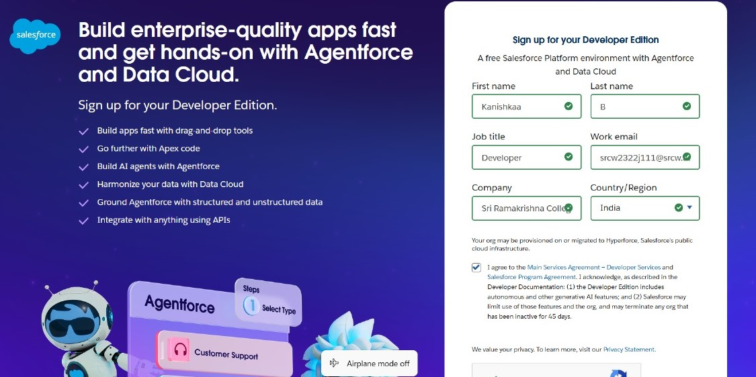­

* Created **Objects** : Customer Details, Appointments, Service records, Billing details and feedback

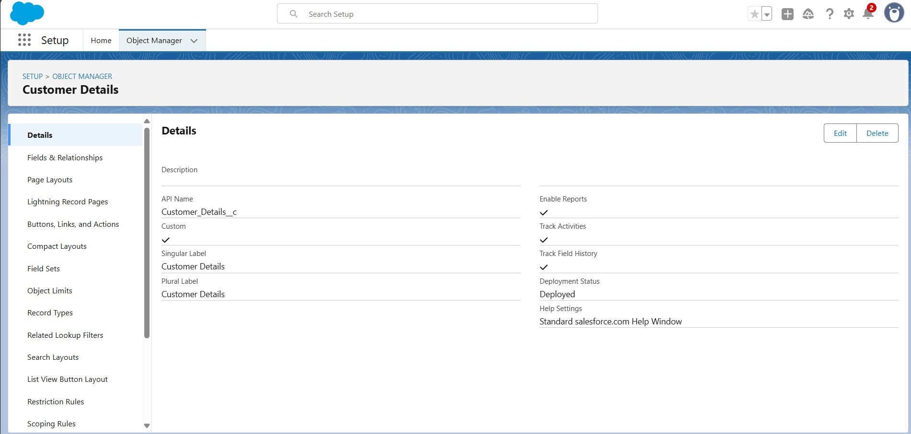

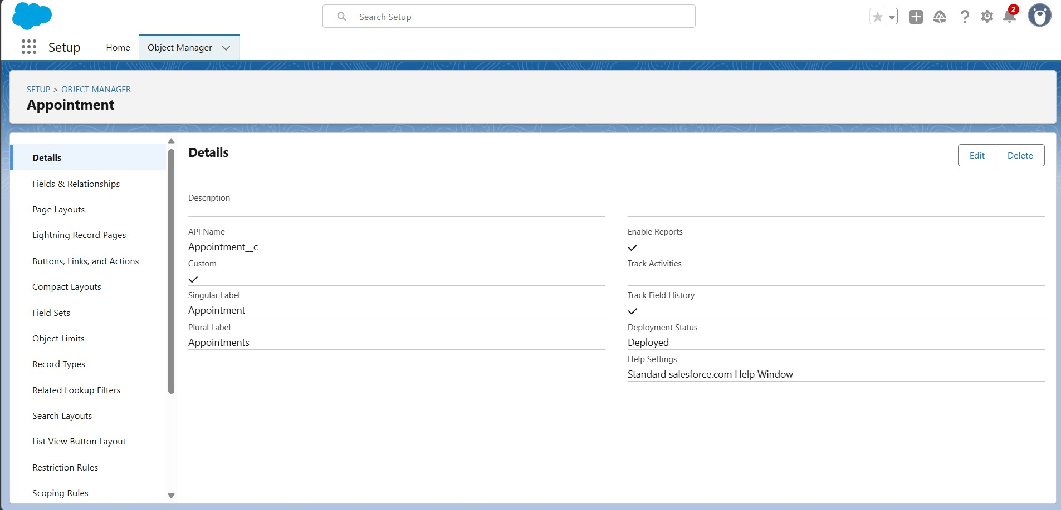

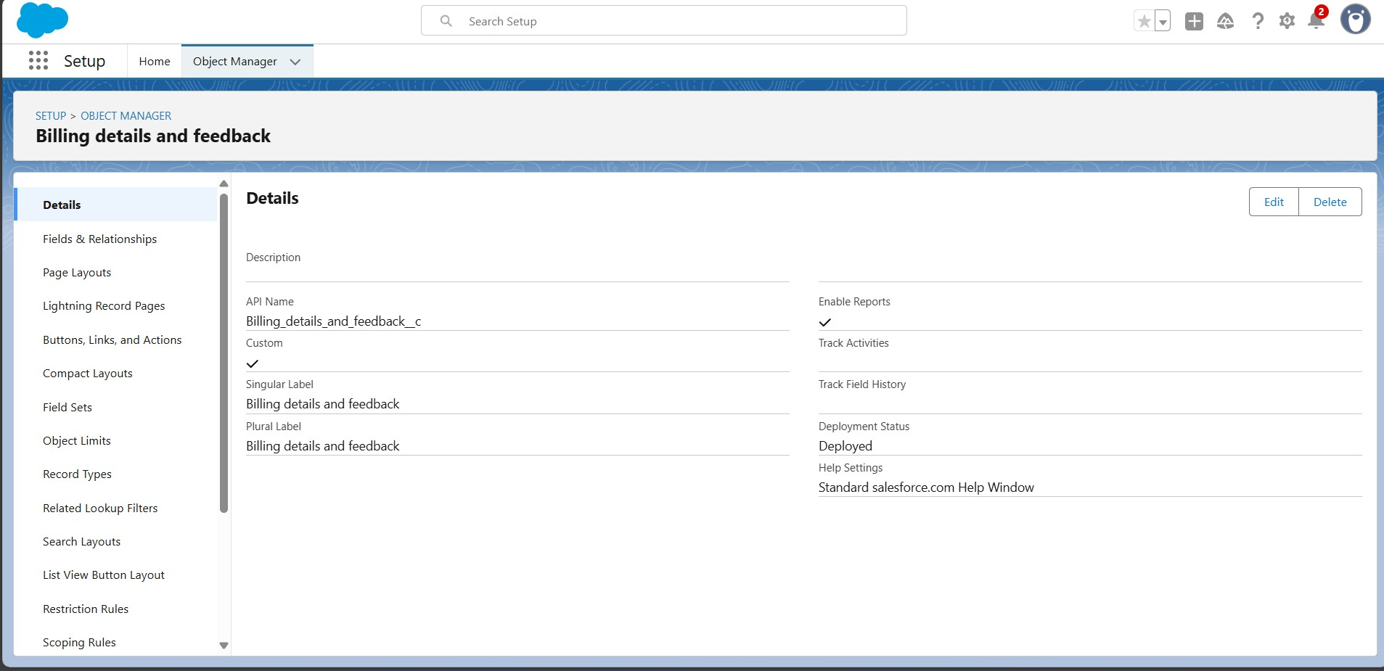

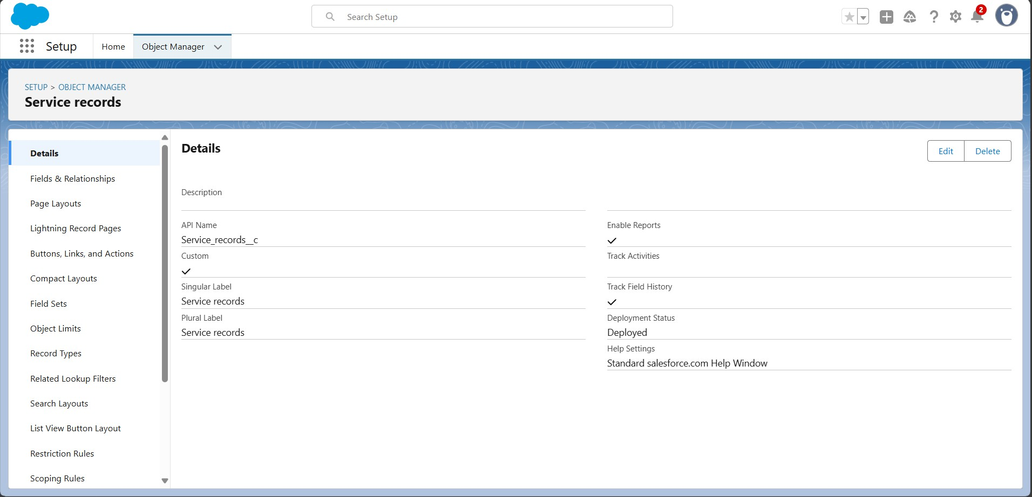

* Created Custom **Tabs** for all the Objects that is been Created

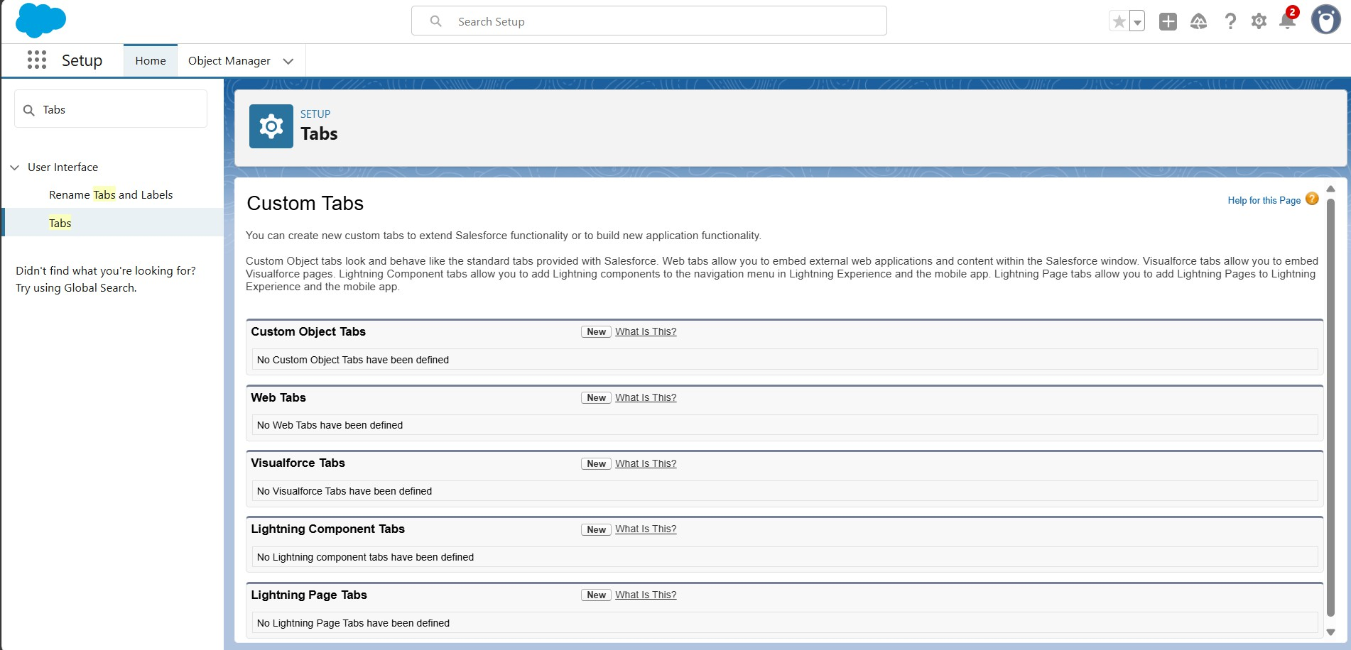

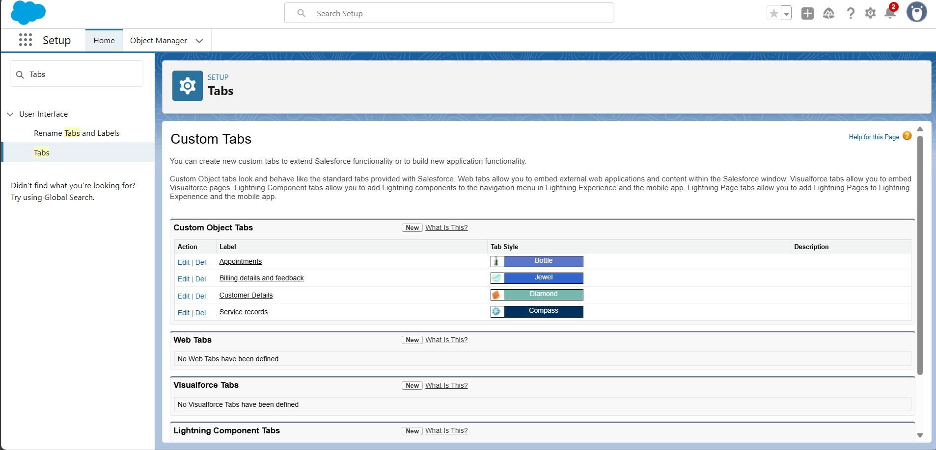

* Developed **Lightning App** with relevant tabs

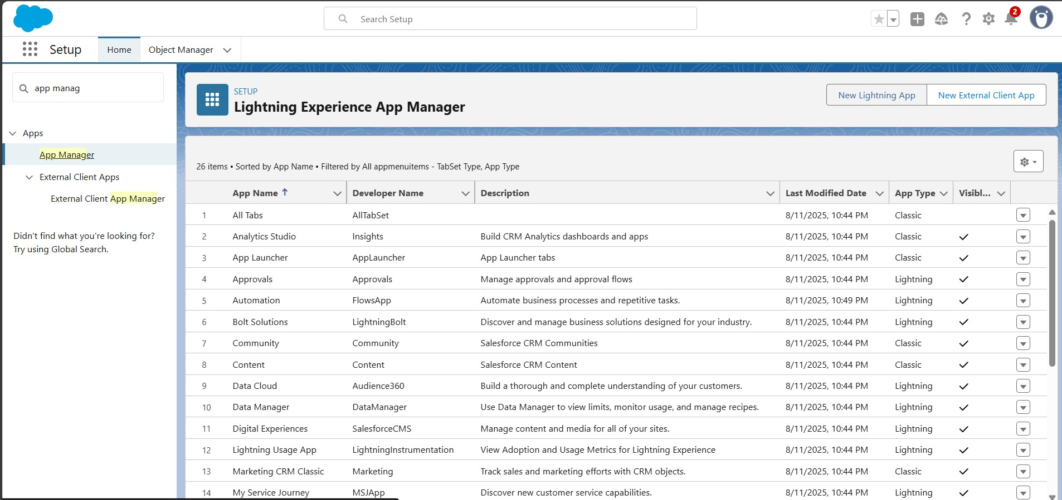

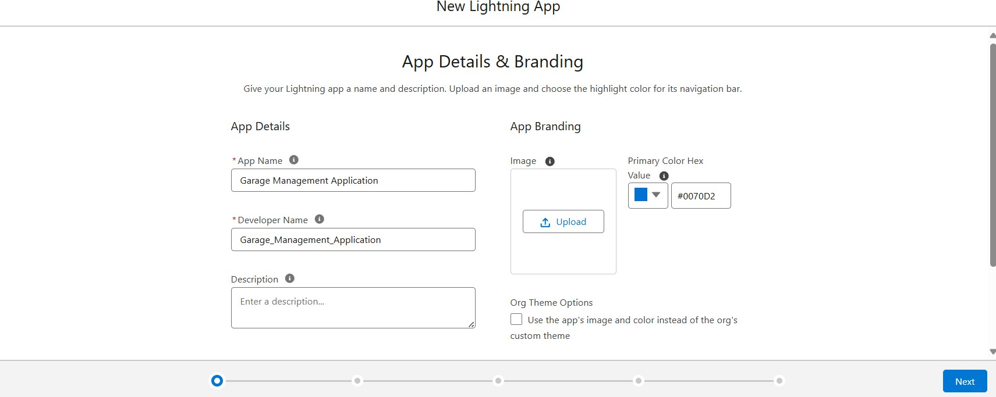

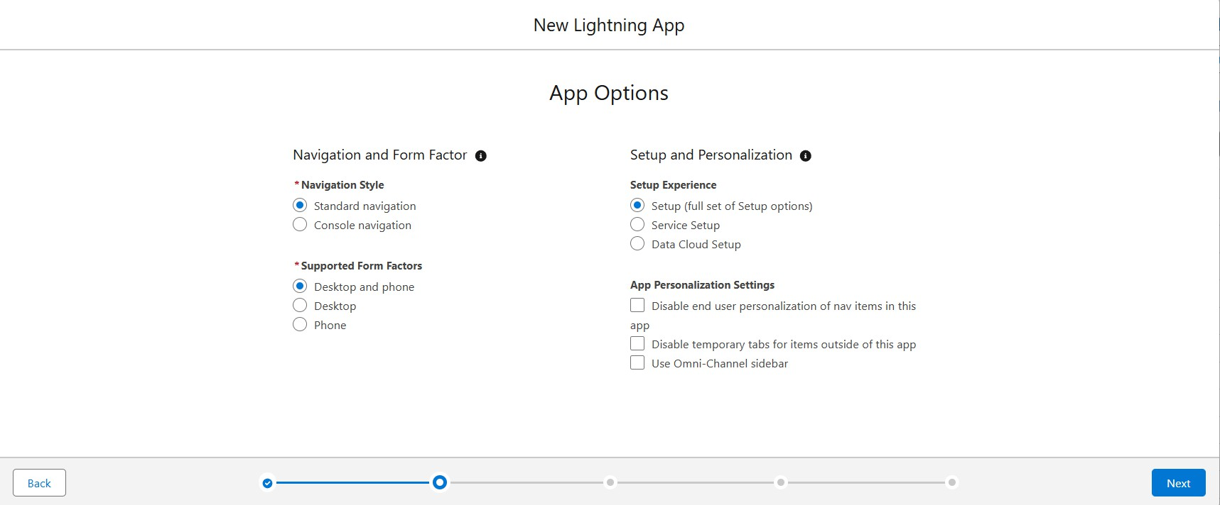

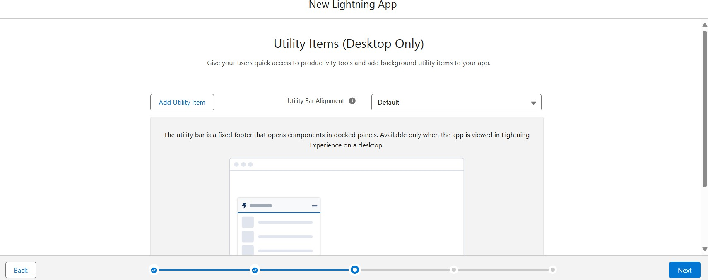

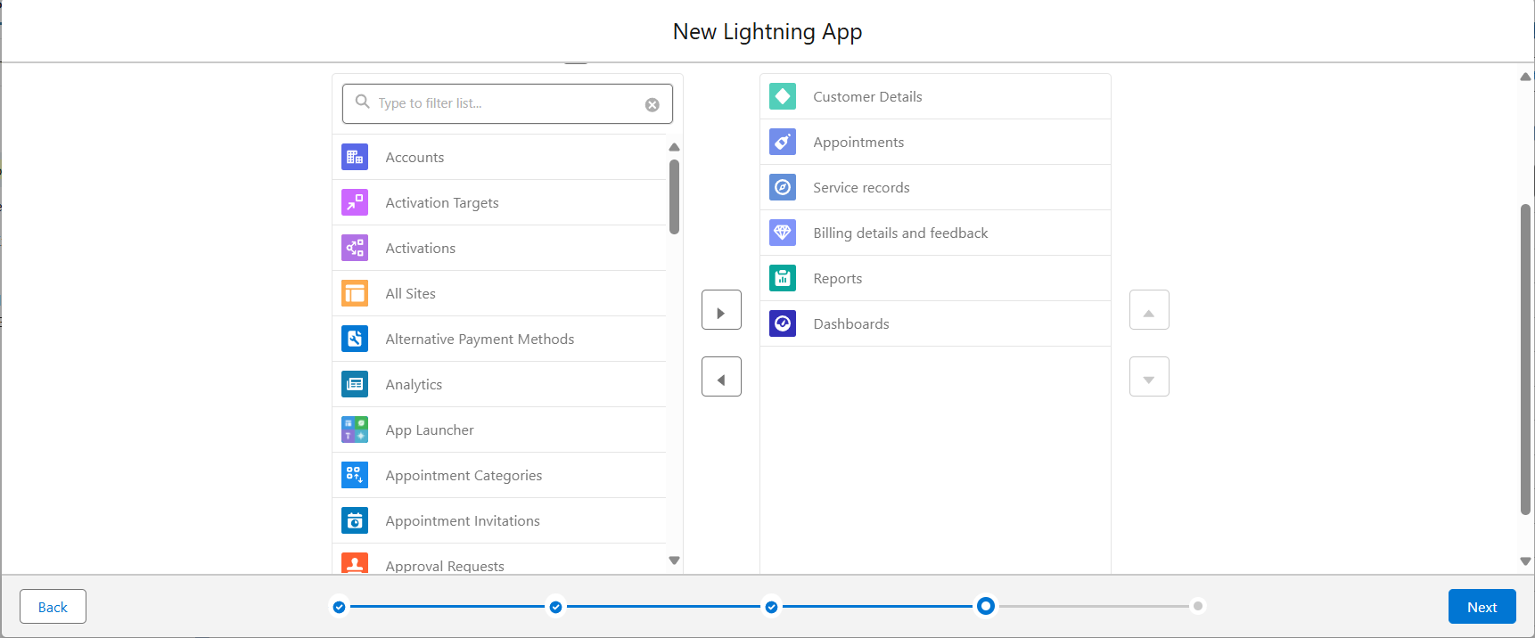

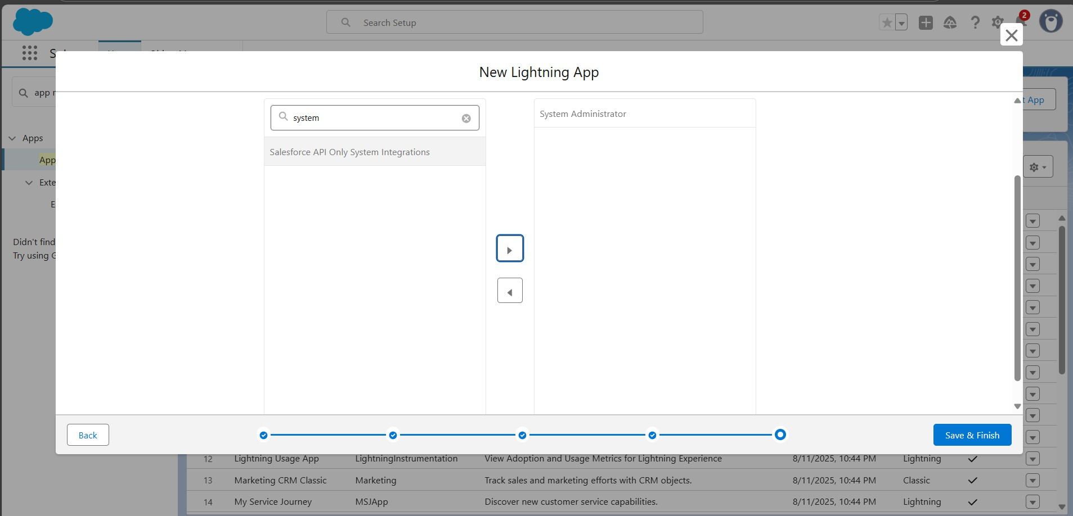

* Created the **fields** for: Customer Details Object, Lookup, Checkbox, Date Fields, Currency, Text, Picklist, Formula and Service Records Object

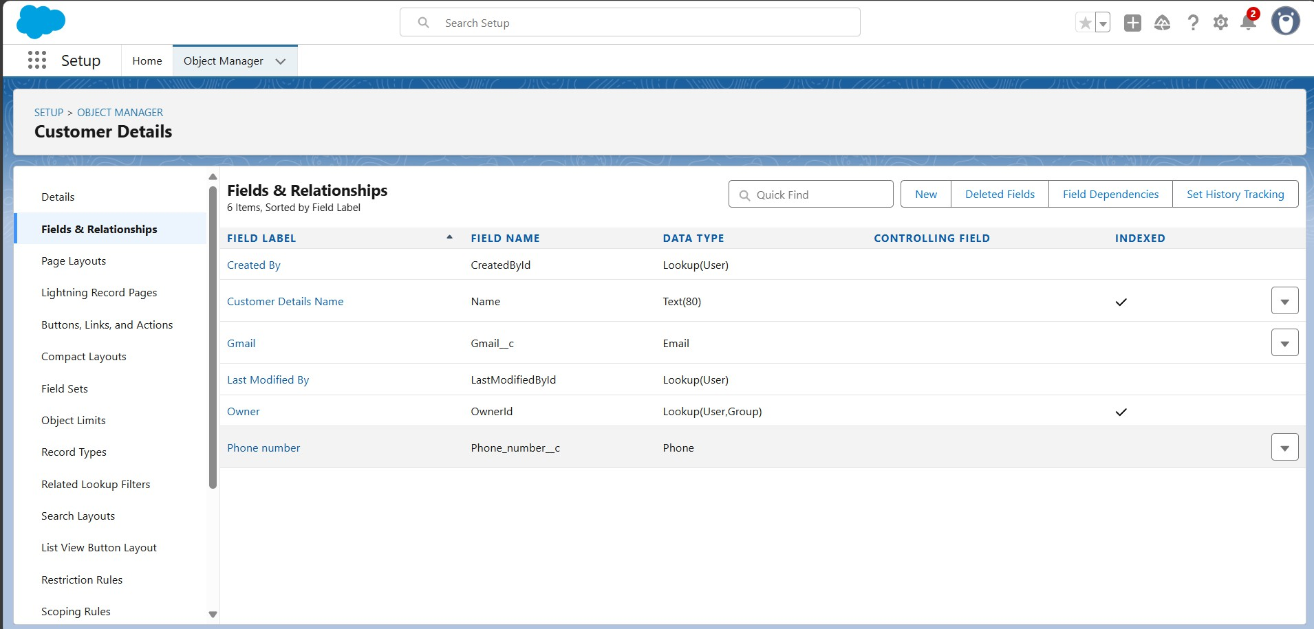

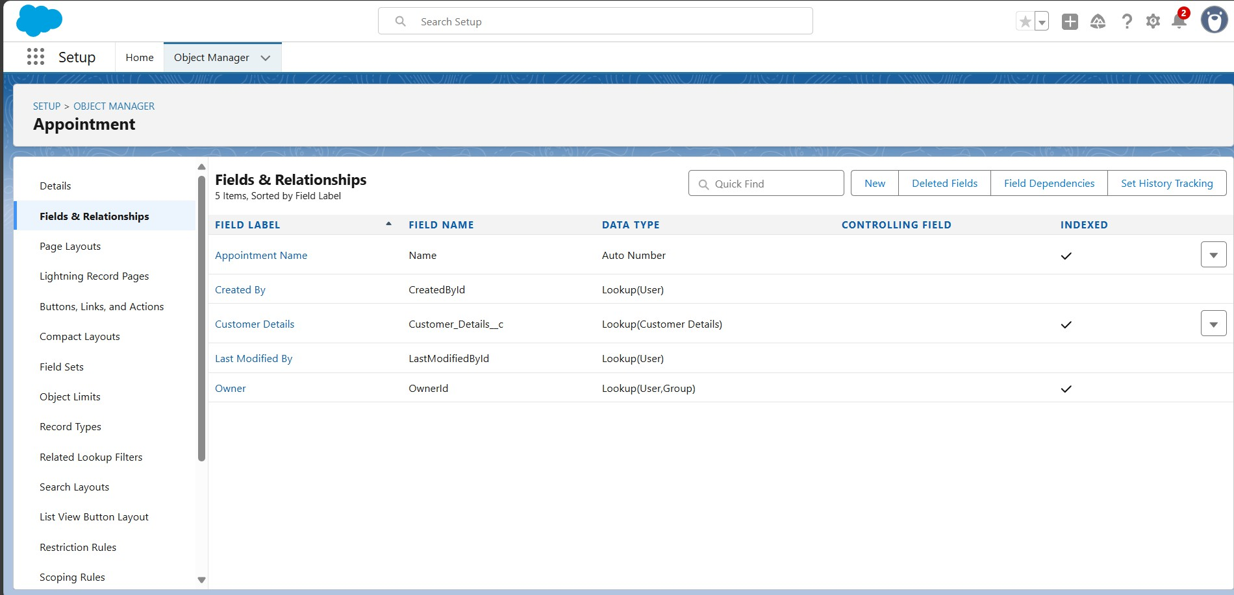

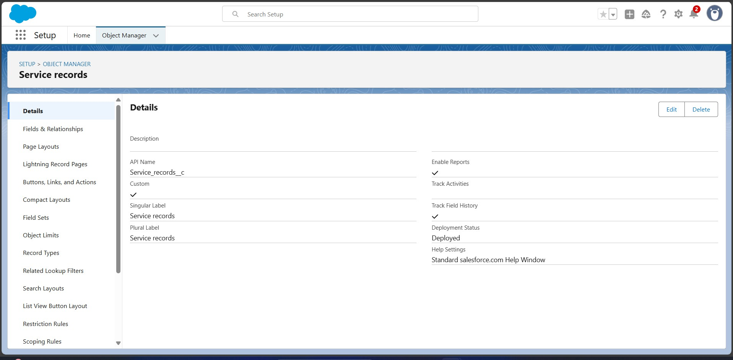

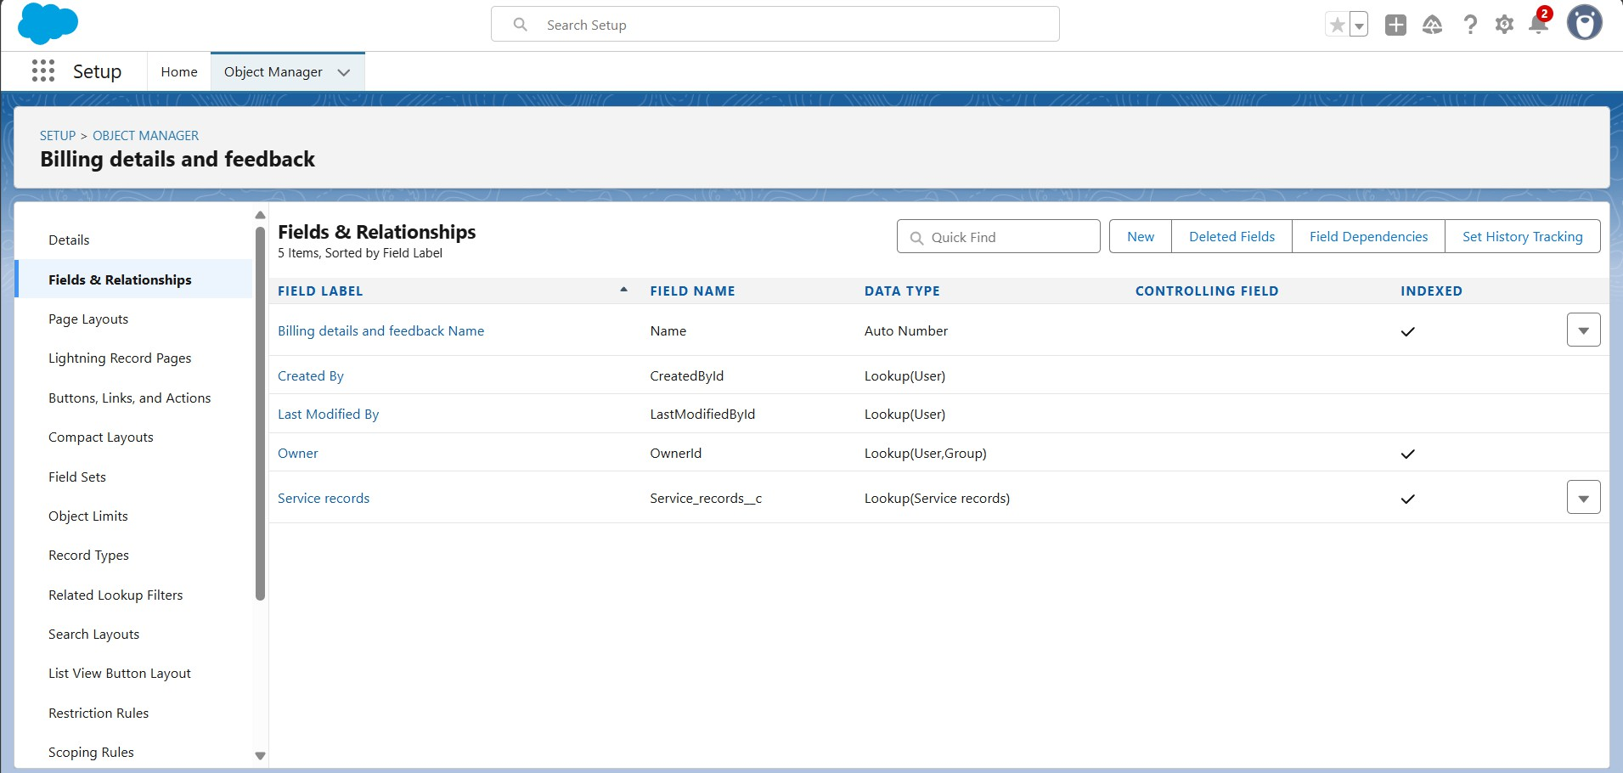

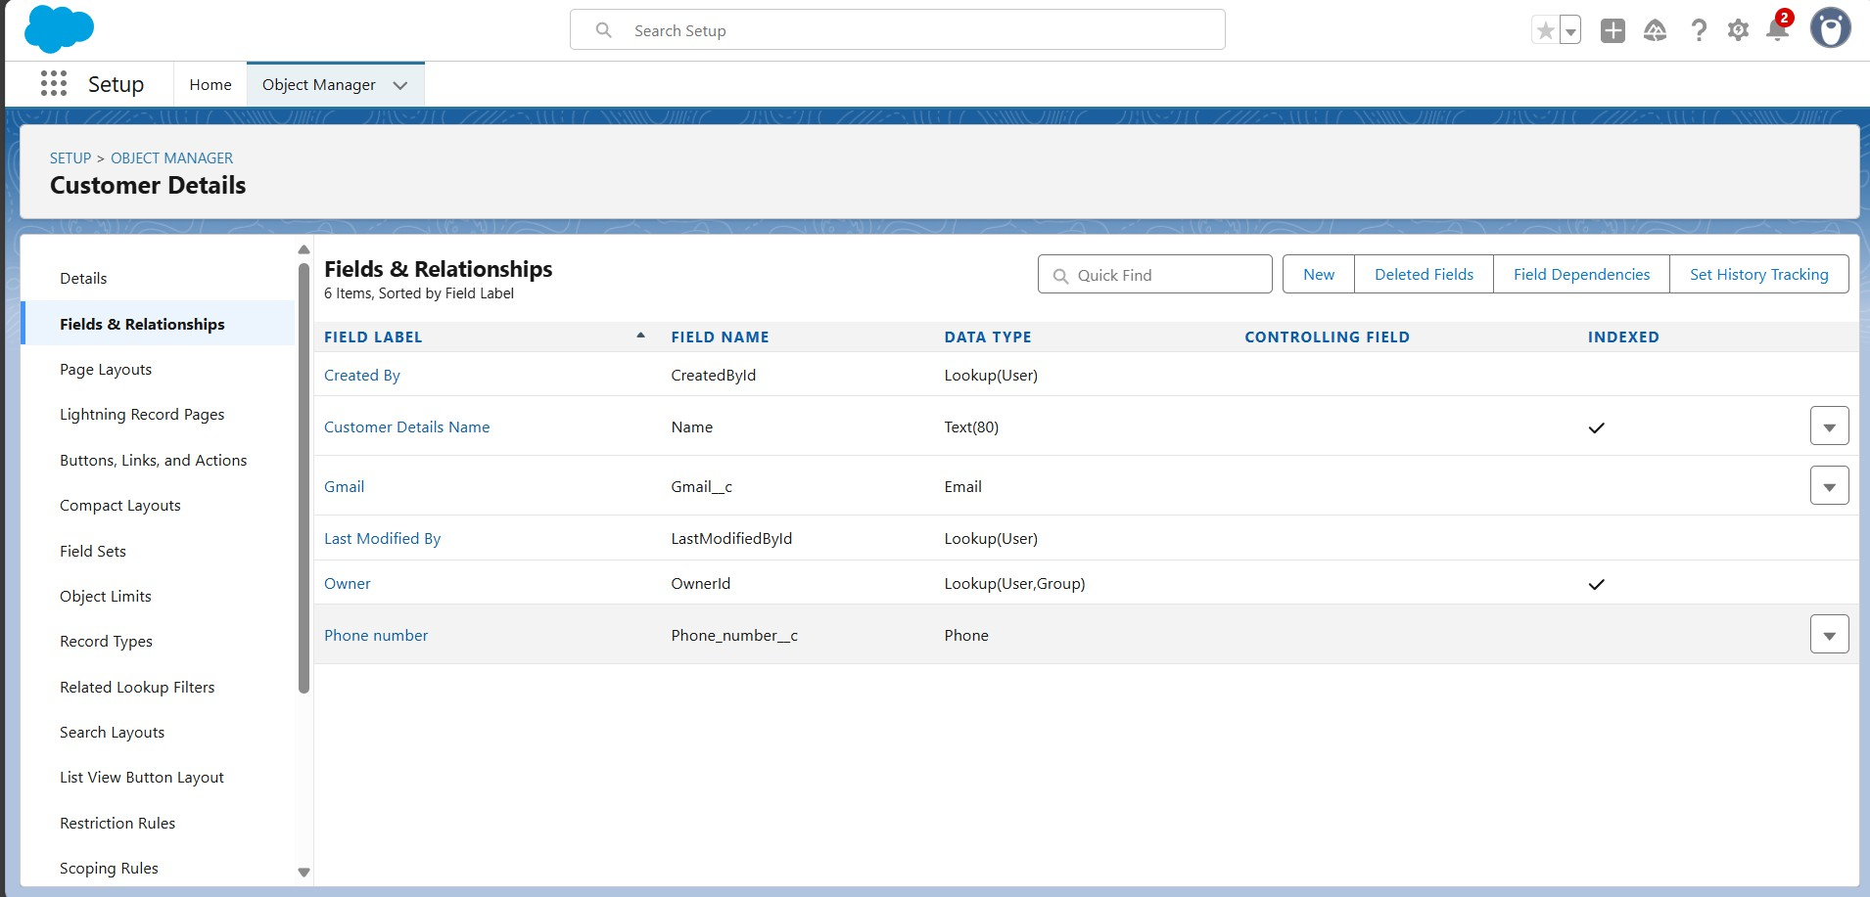

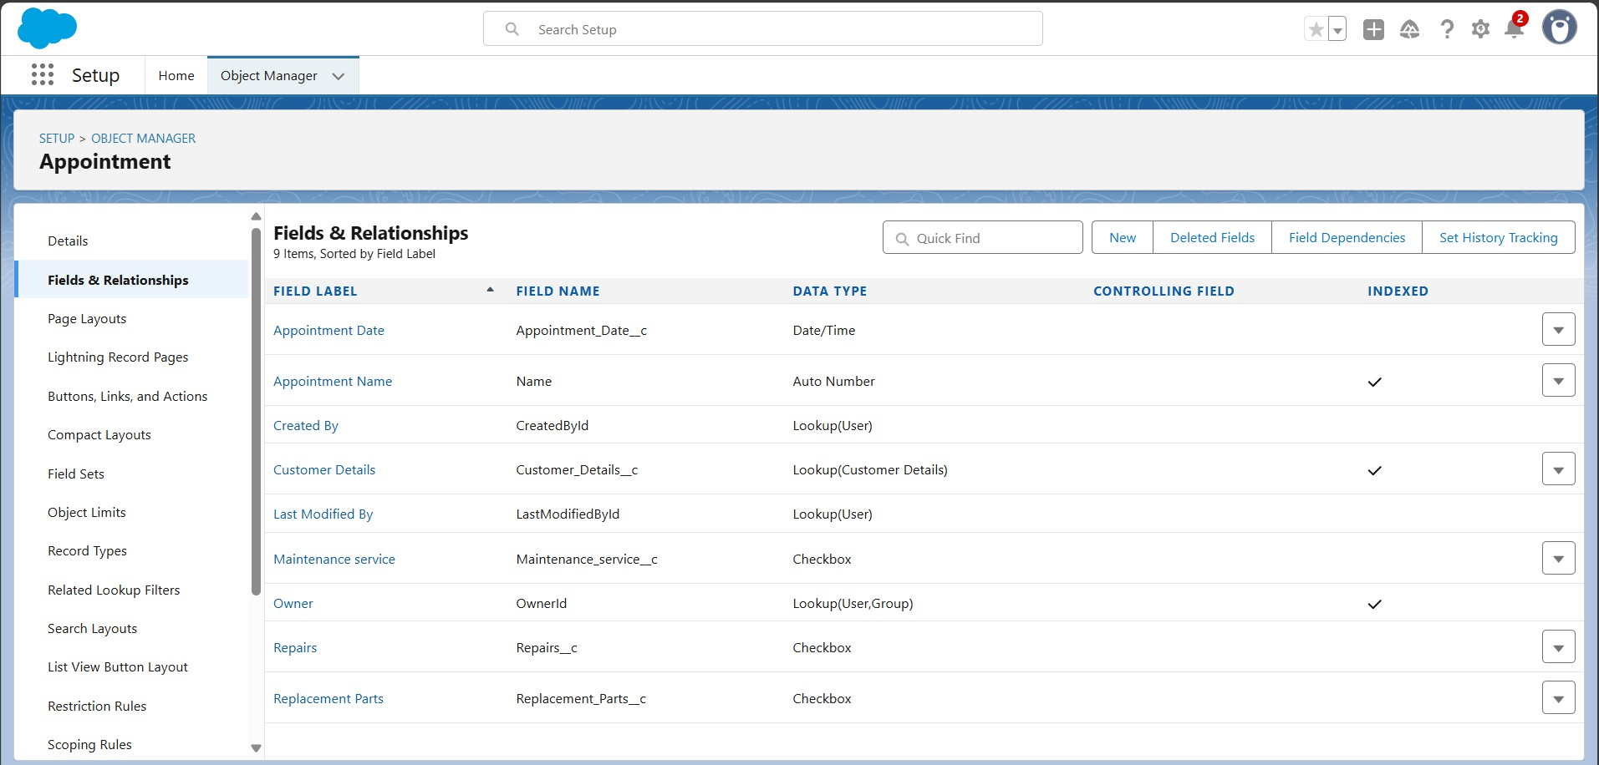

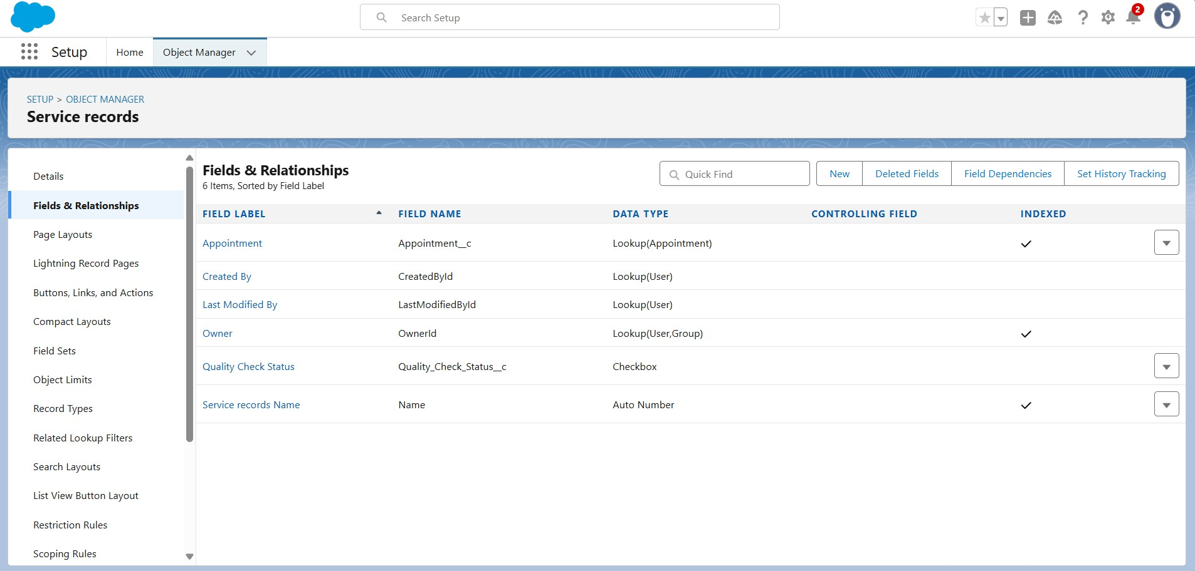

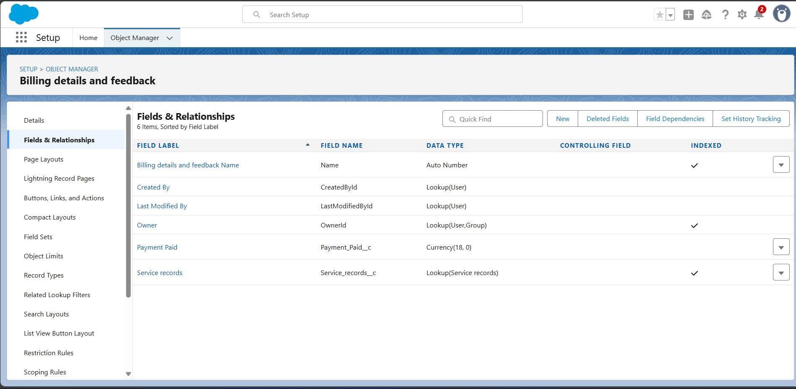

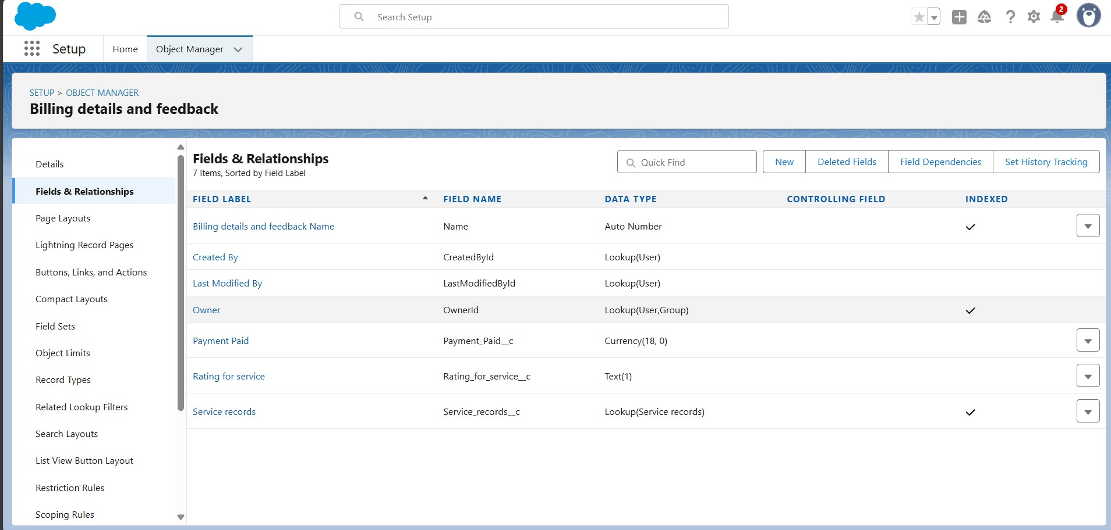

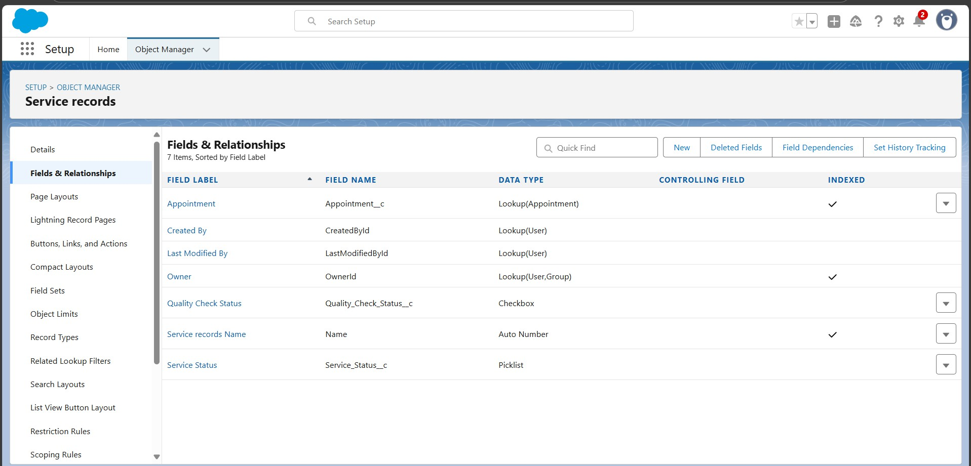

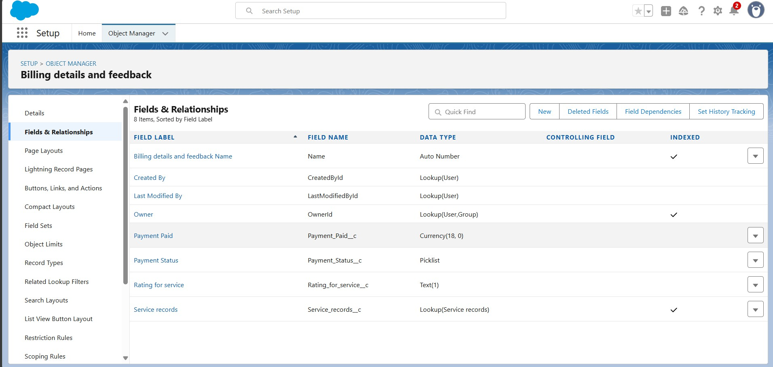

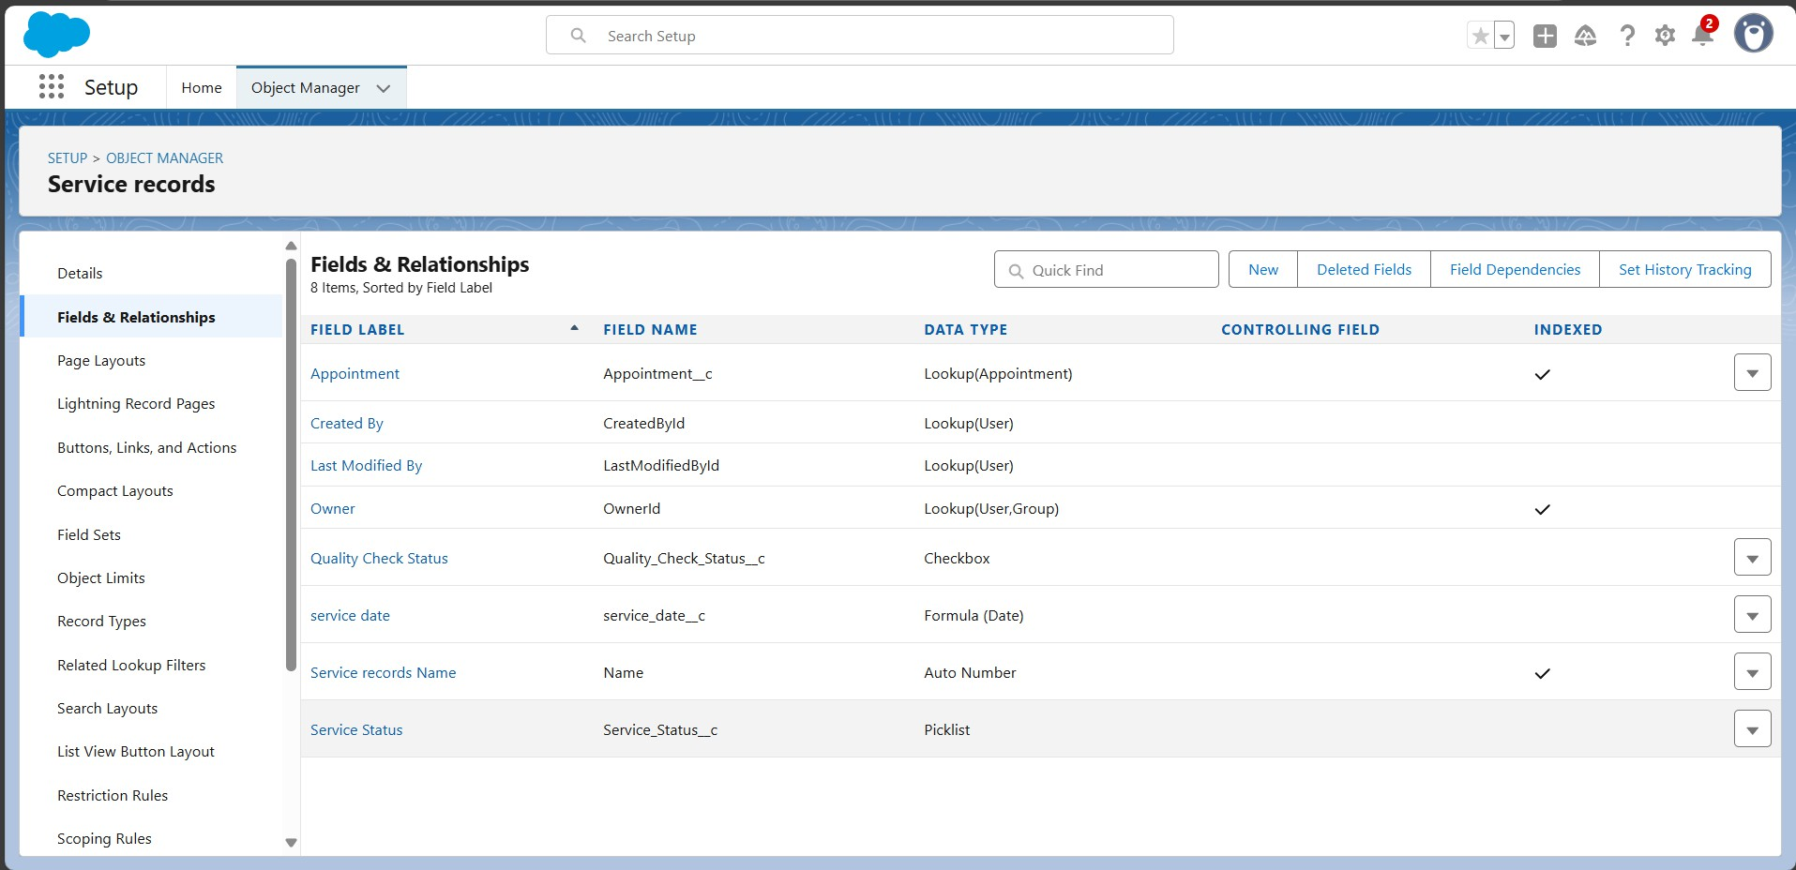

* Created the **Validation rule** for: Appointment object, Billing Details and Feedback objects.

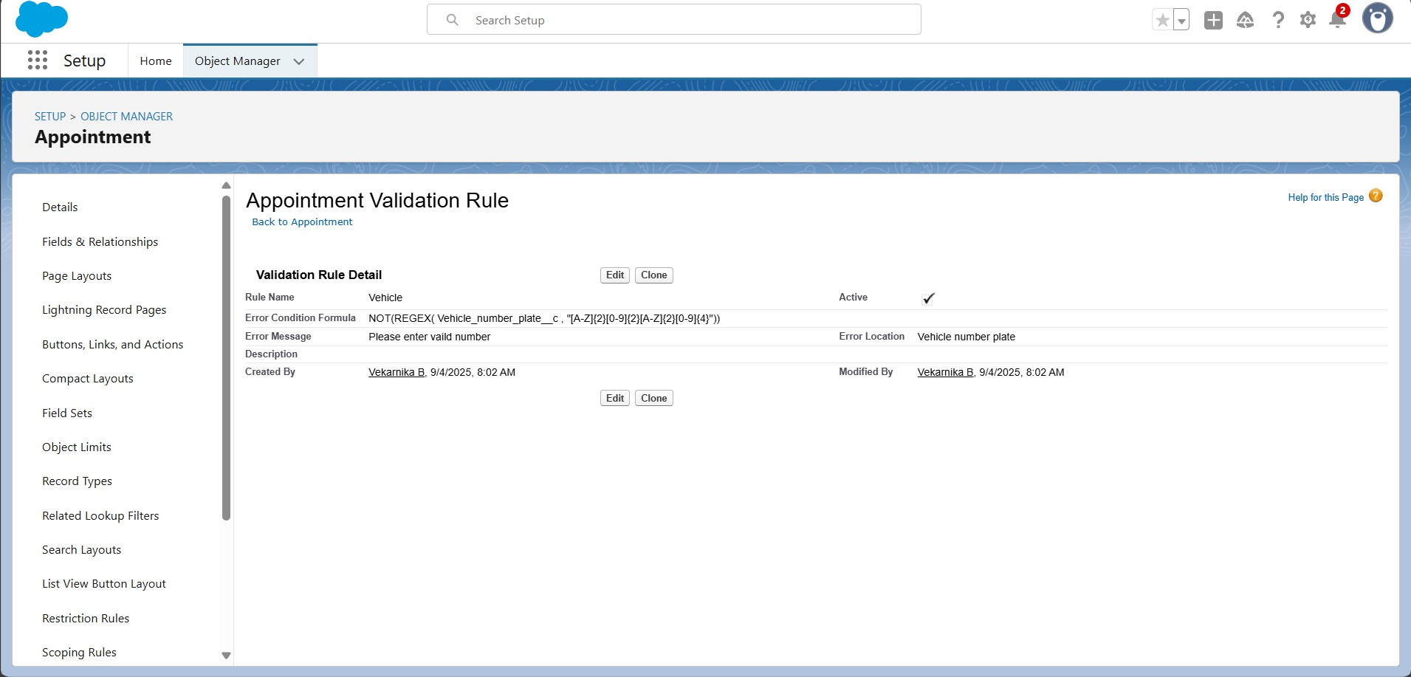

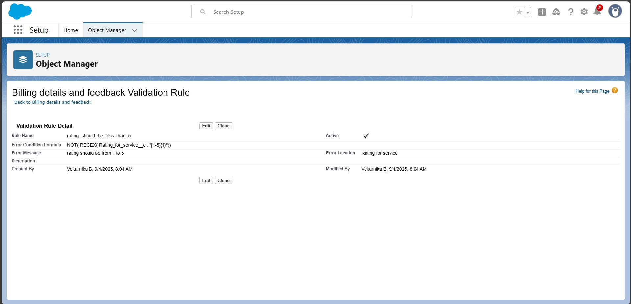

* Create **duplicate rules** to Customer details Object for: Matching and Duplicate.

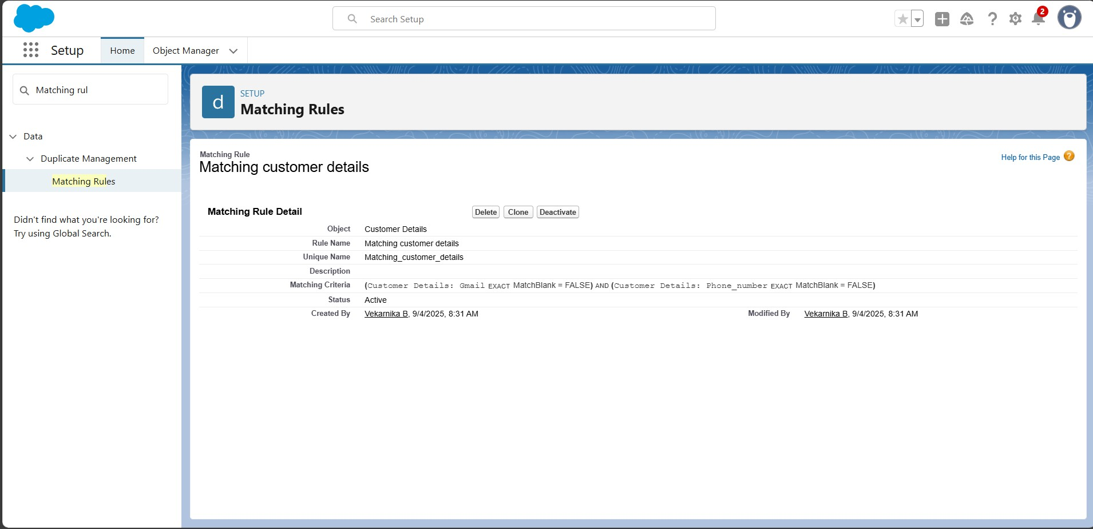

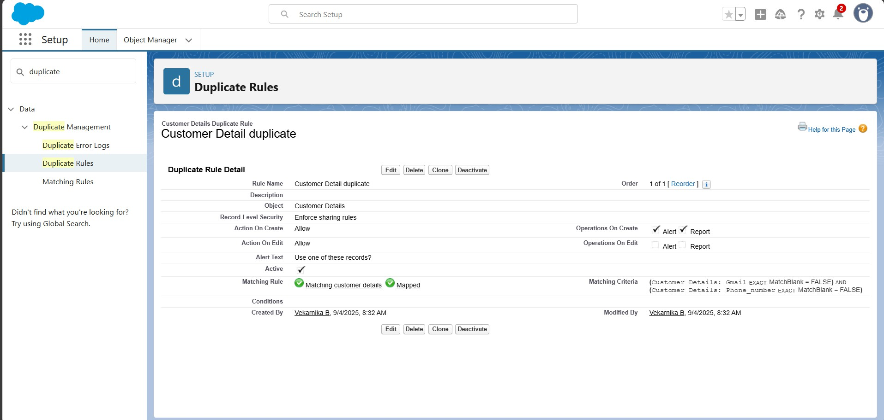

* + Created **Profiles** for: Manager and Sales Person.

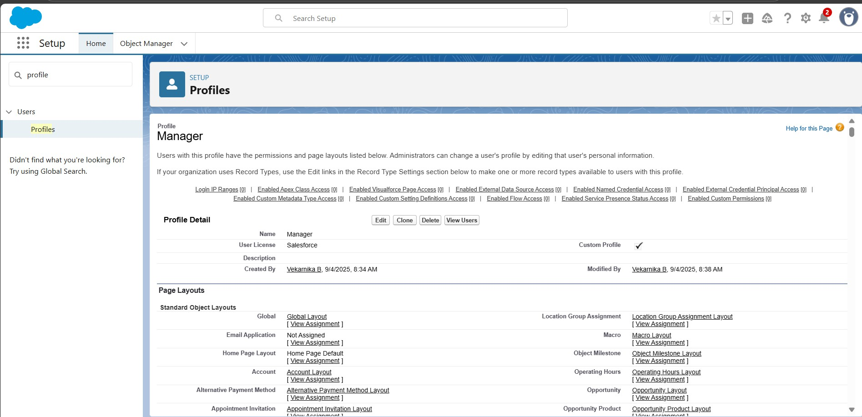

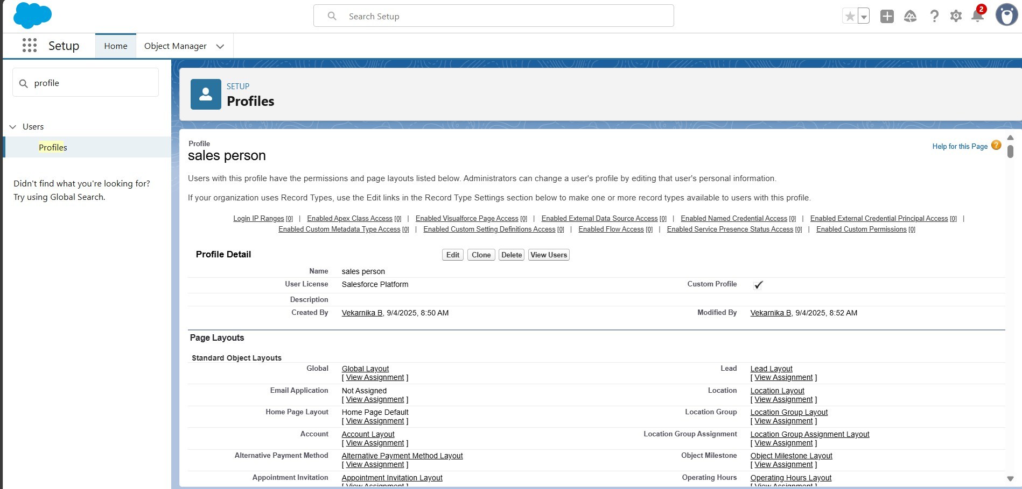

* Created **Roles and Role Hierarchy** for: Manager and Another.

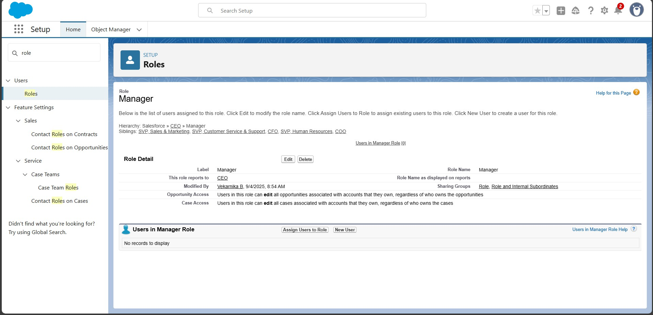

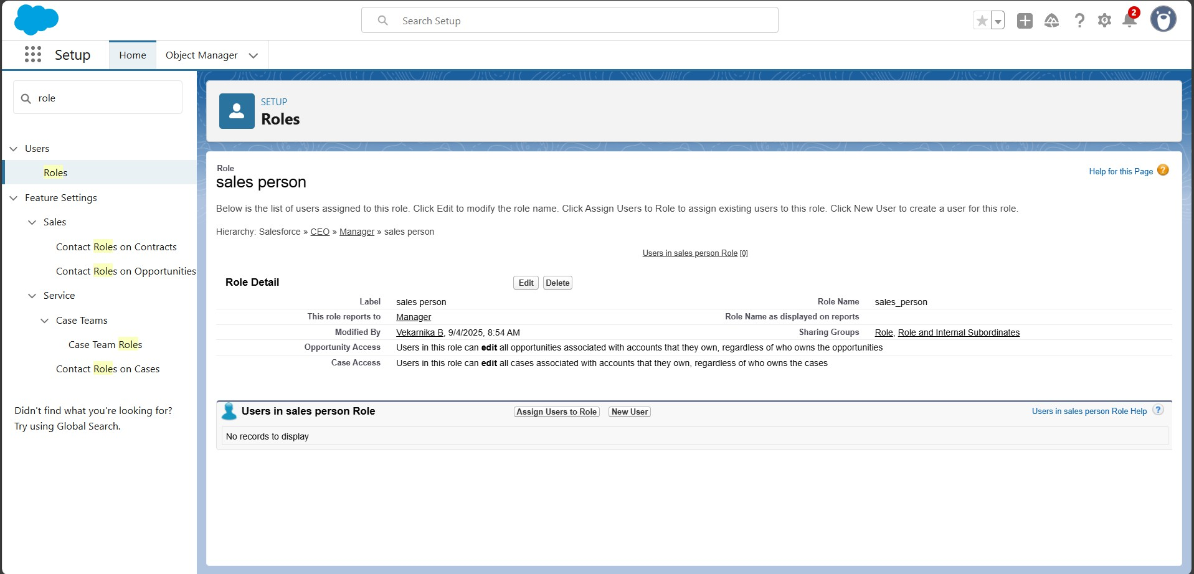

* Created **Users** and Another user.

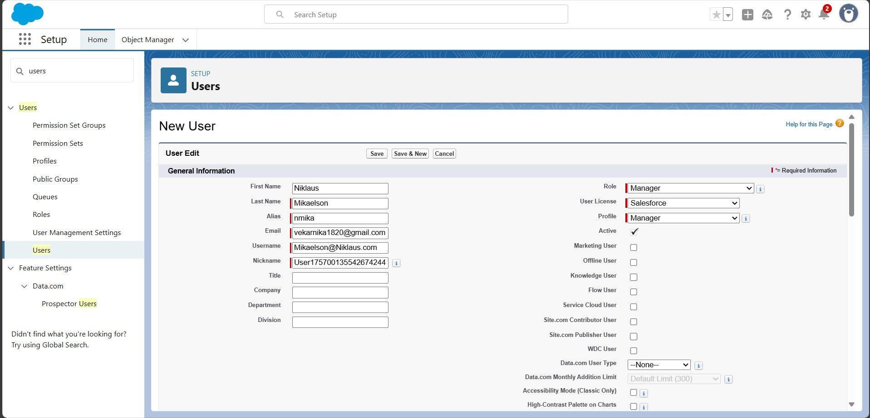

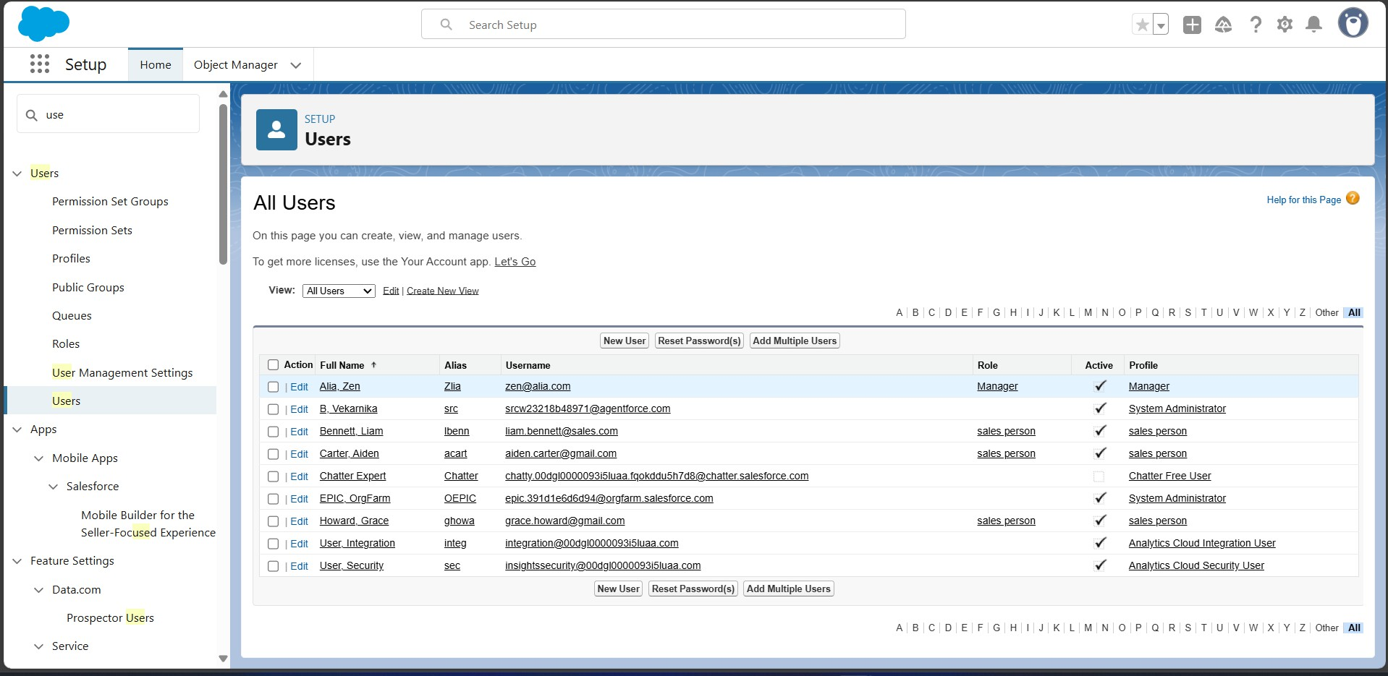

* Created new **Public Groups**.

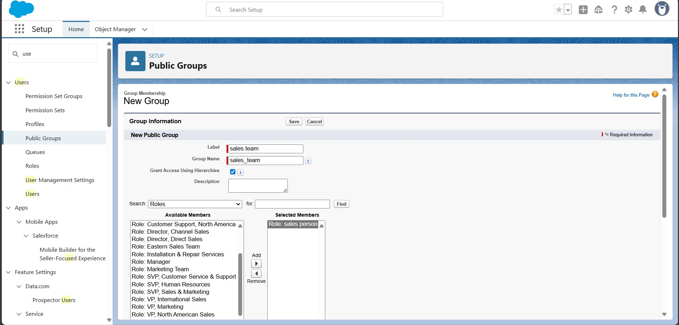

* Created the **Sharing Setting**.

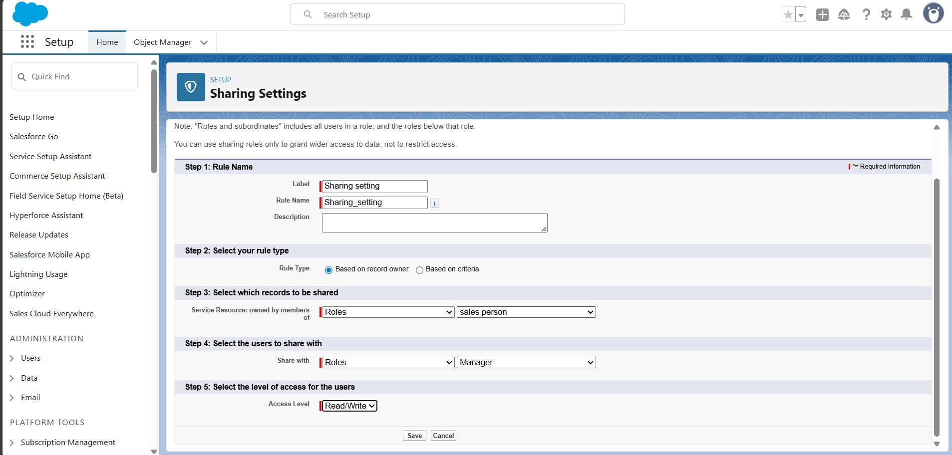

* Created **Flow** - Billing amount flow.

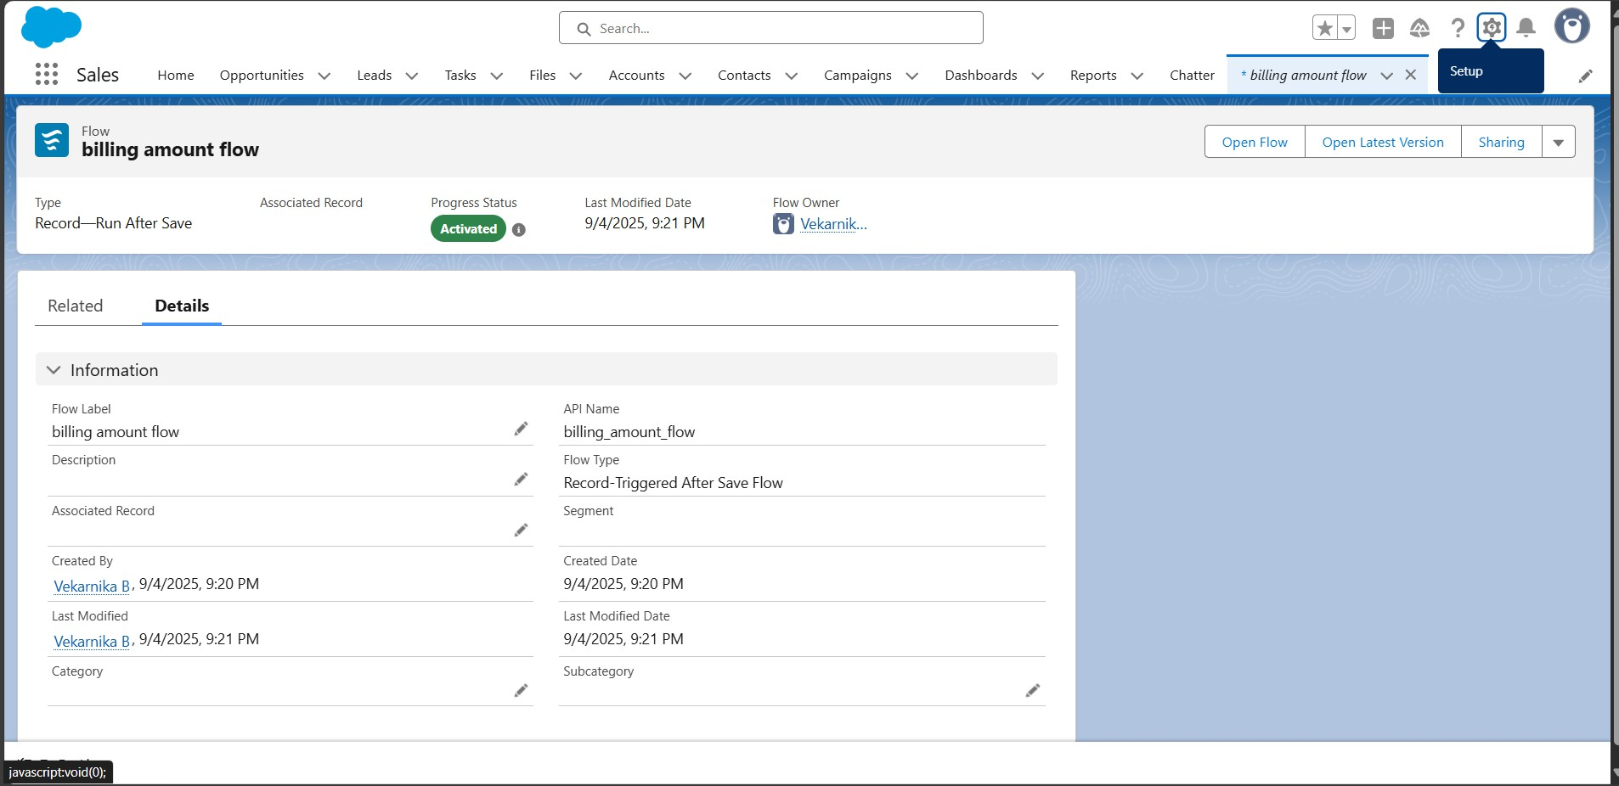

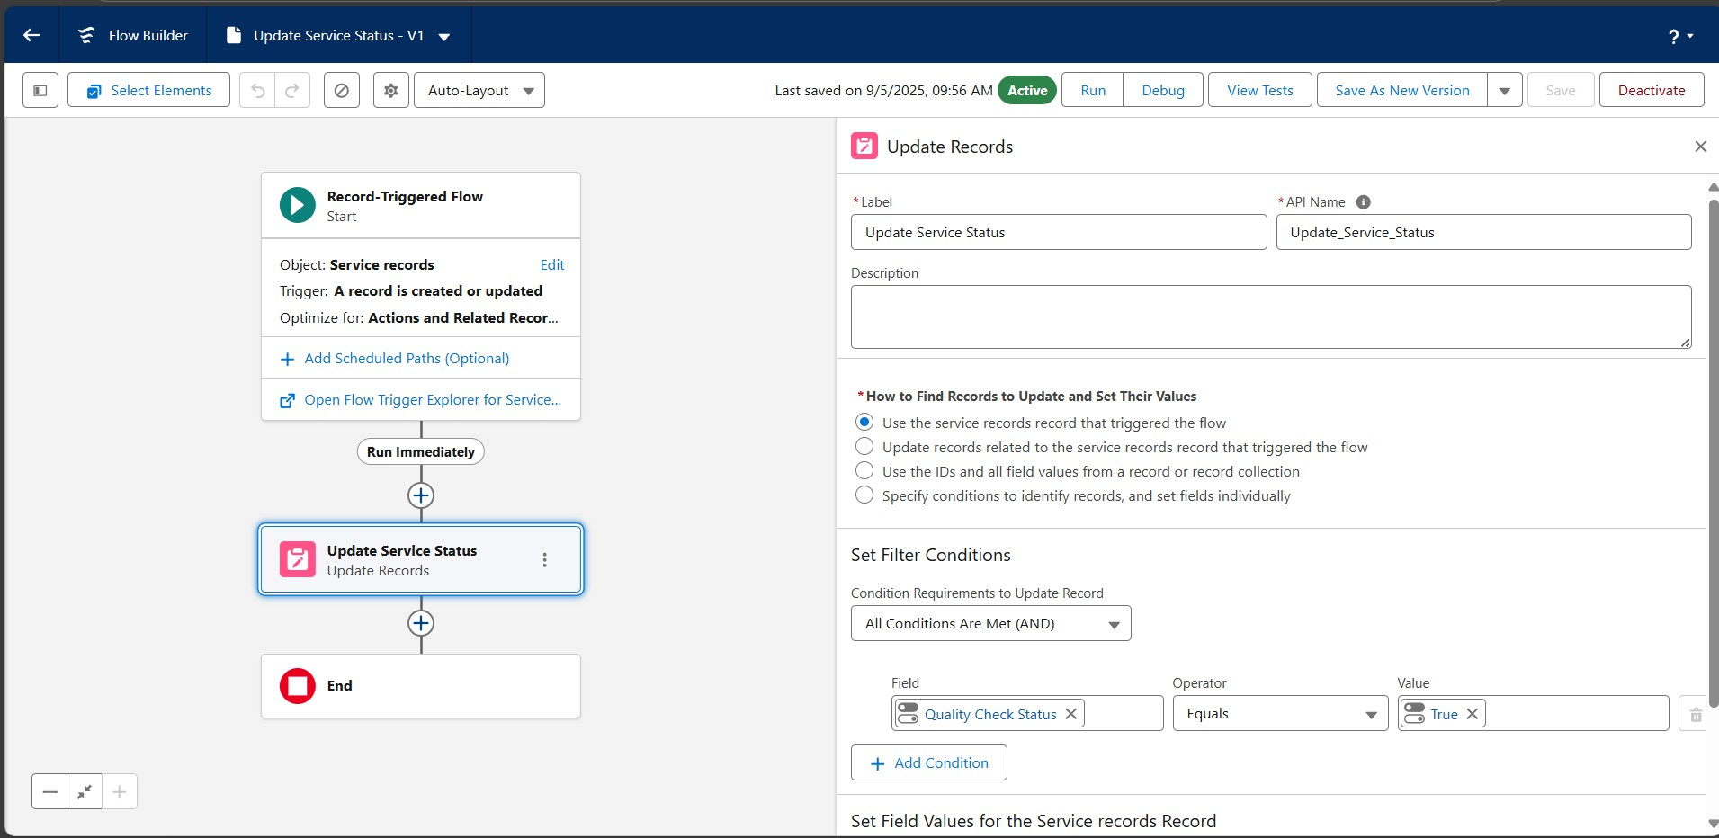

* Developed **Apex Triggers**:

Created Apex Class called AmountDistribustionHandler.

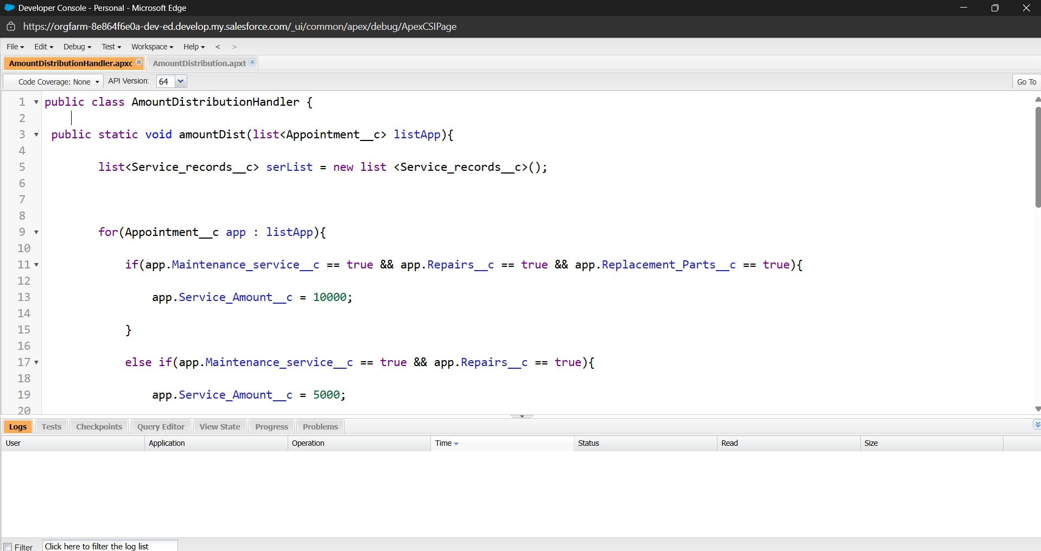

Created an Apex trigger called AmountDistribustion.

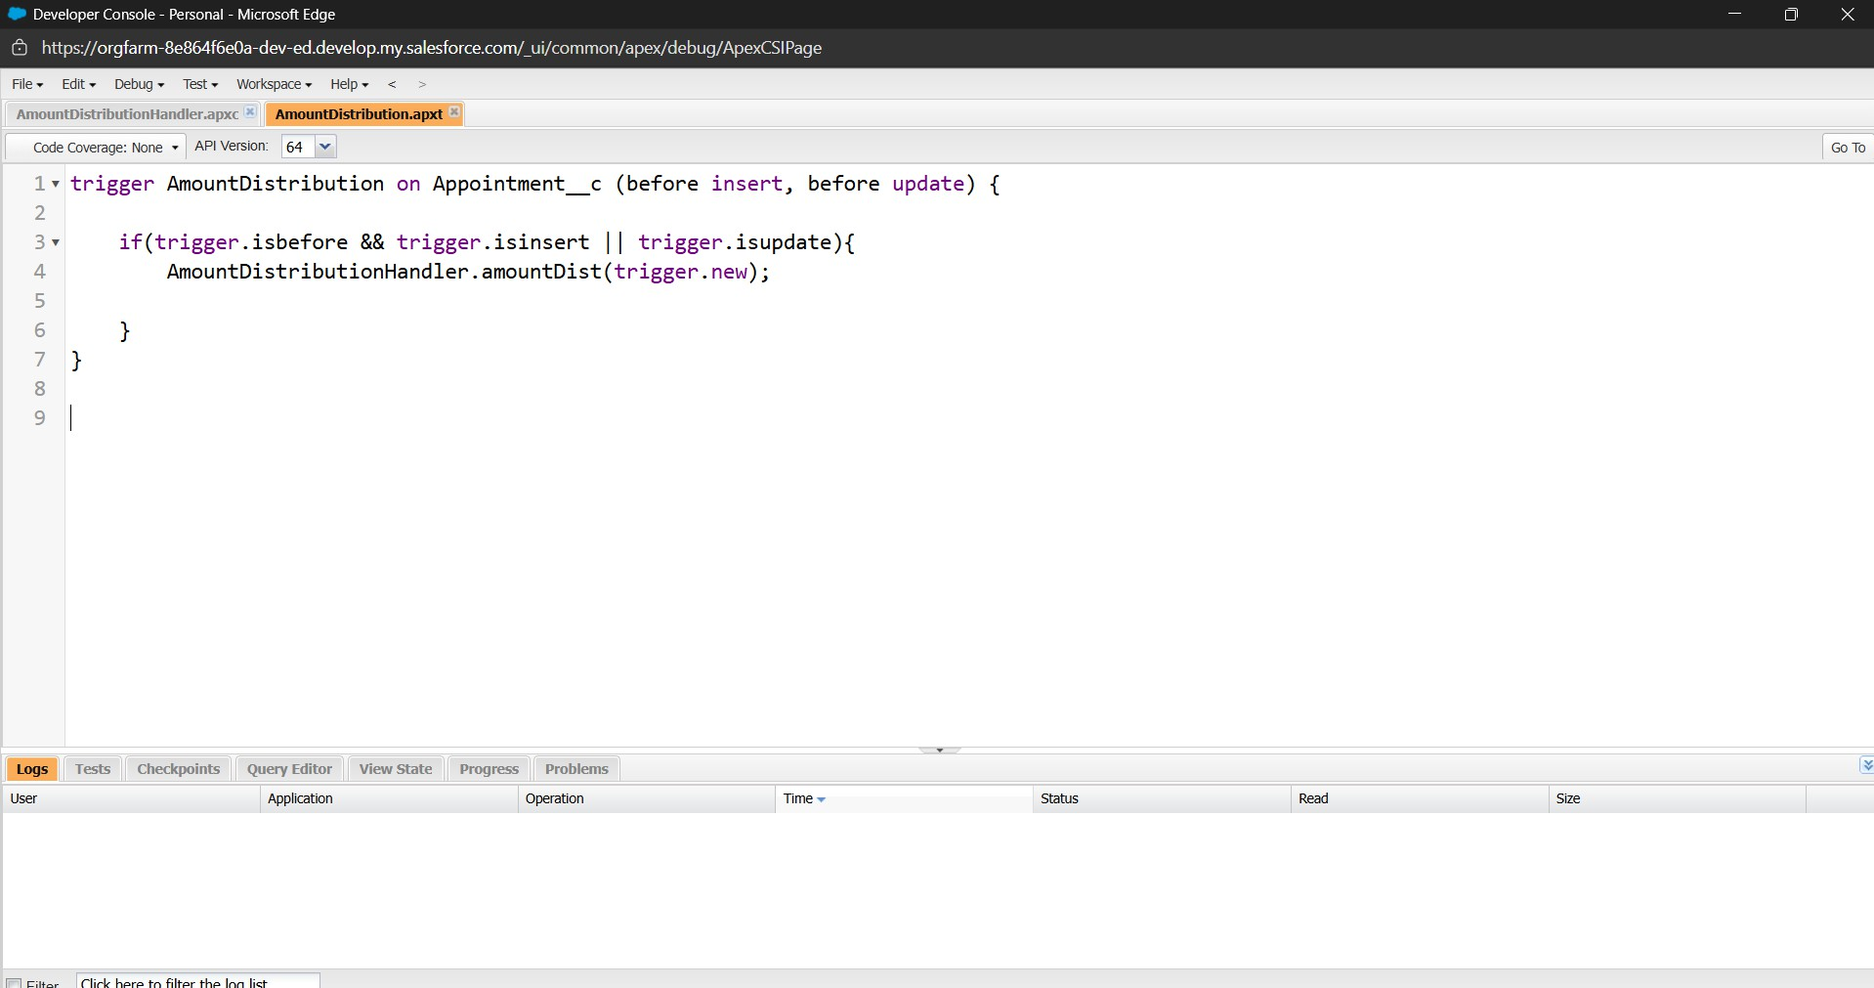

* Created **Report** folders, Report type, Report and shared Report folder.

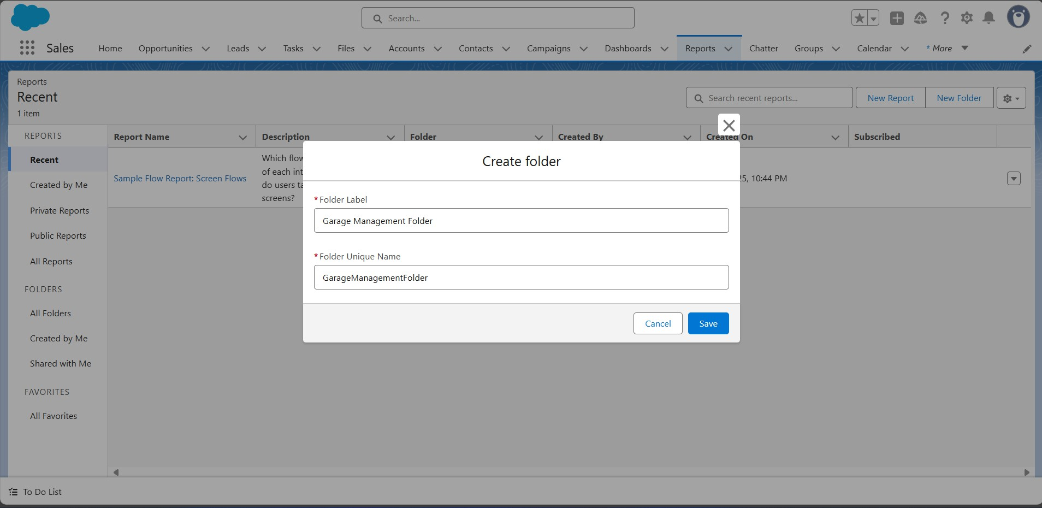

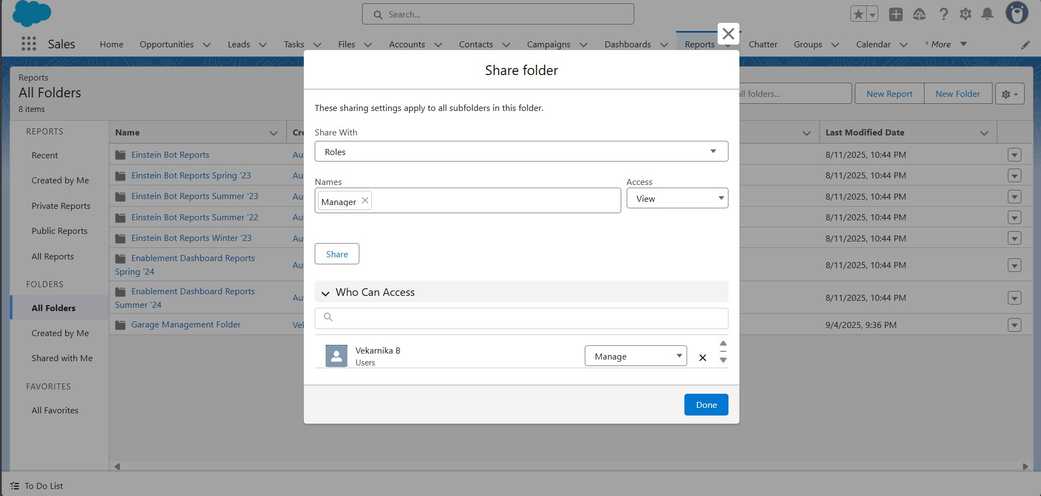

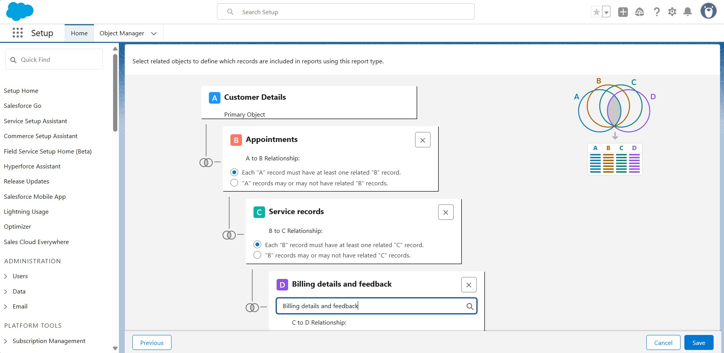

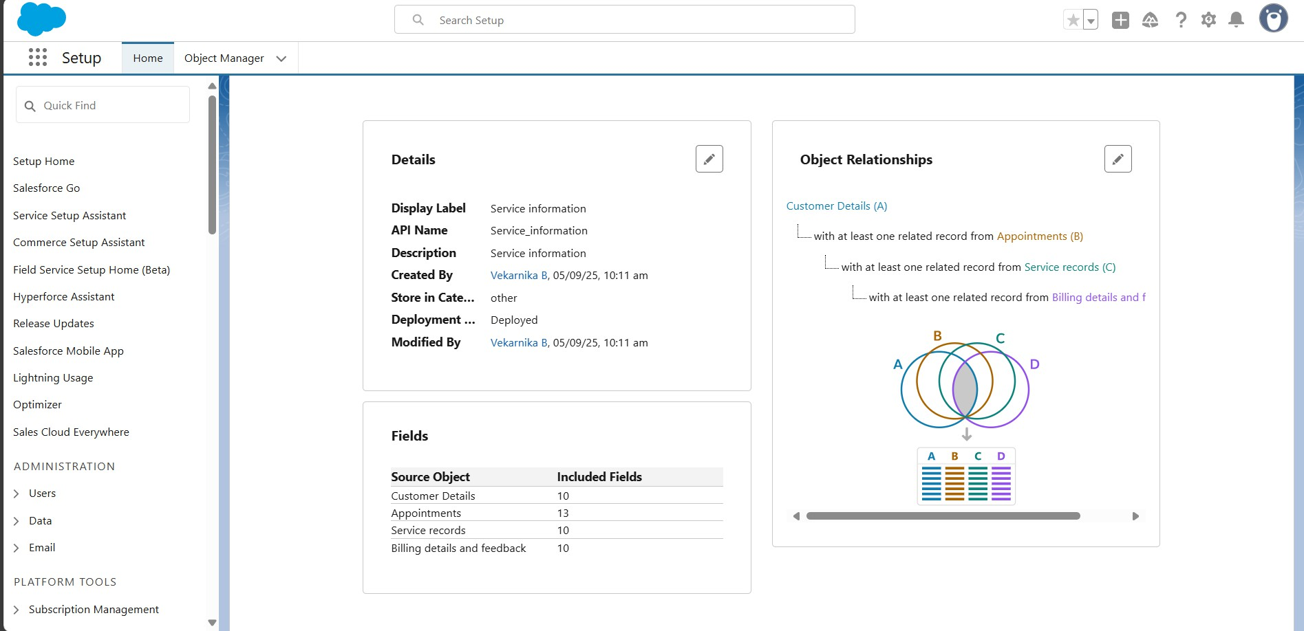

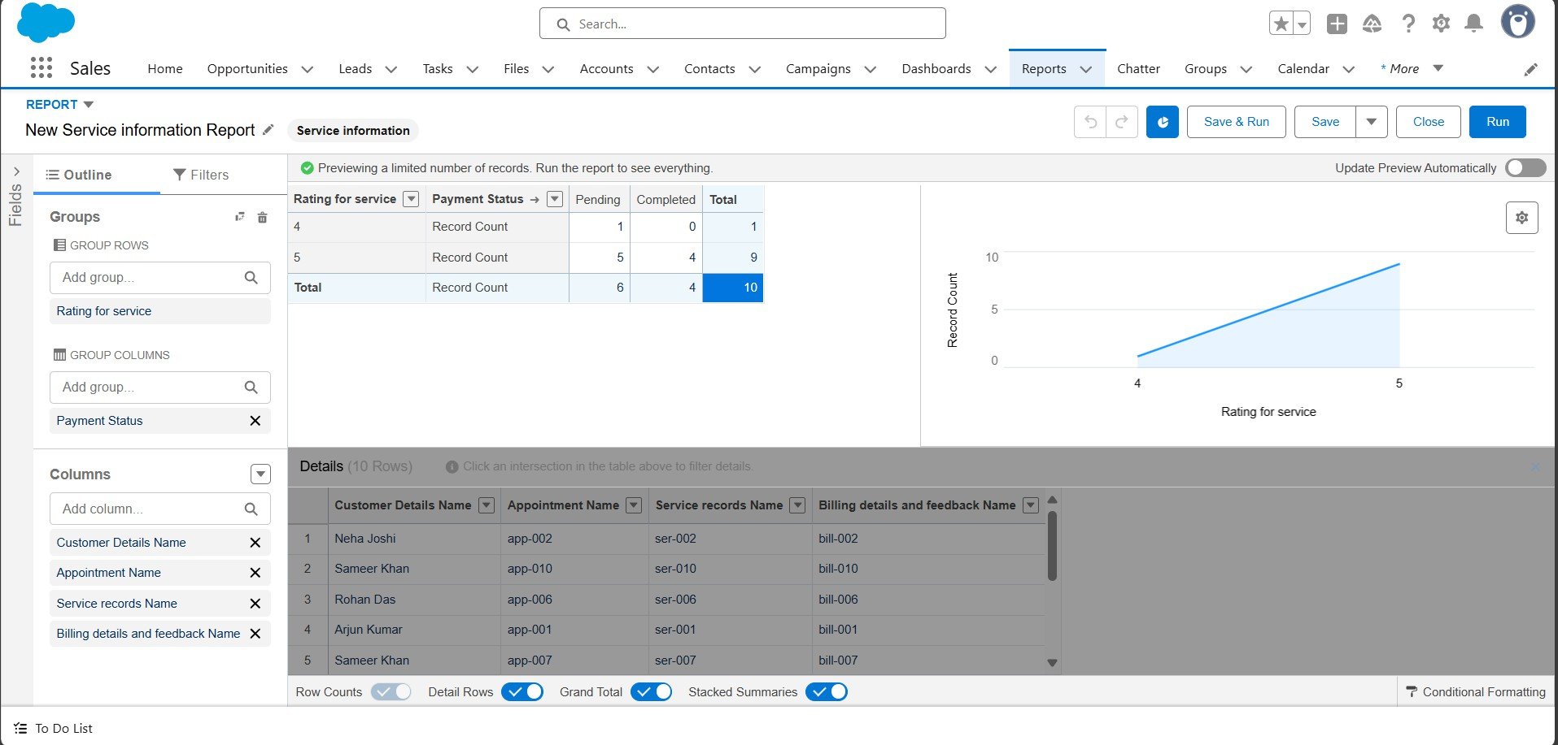

* Created **Dashboards** and Dashboard folders.

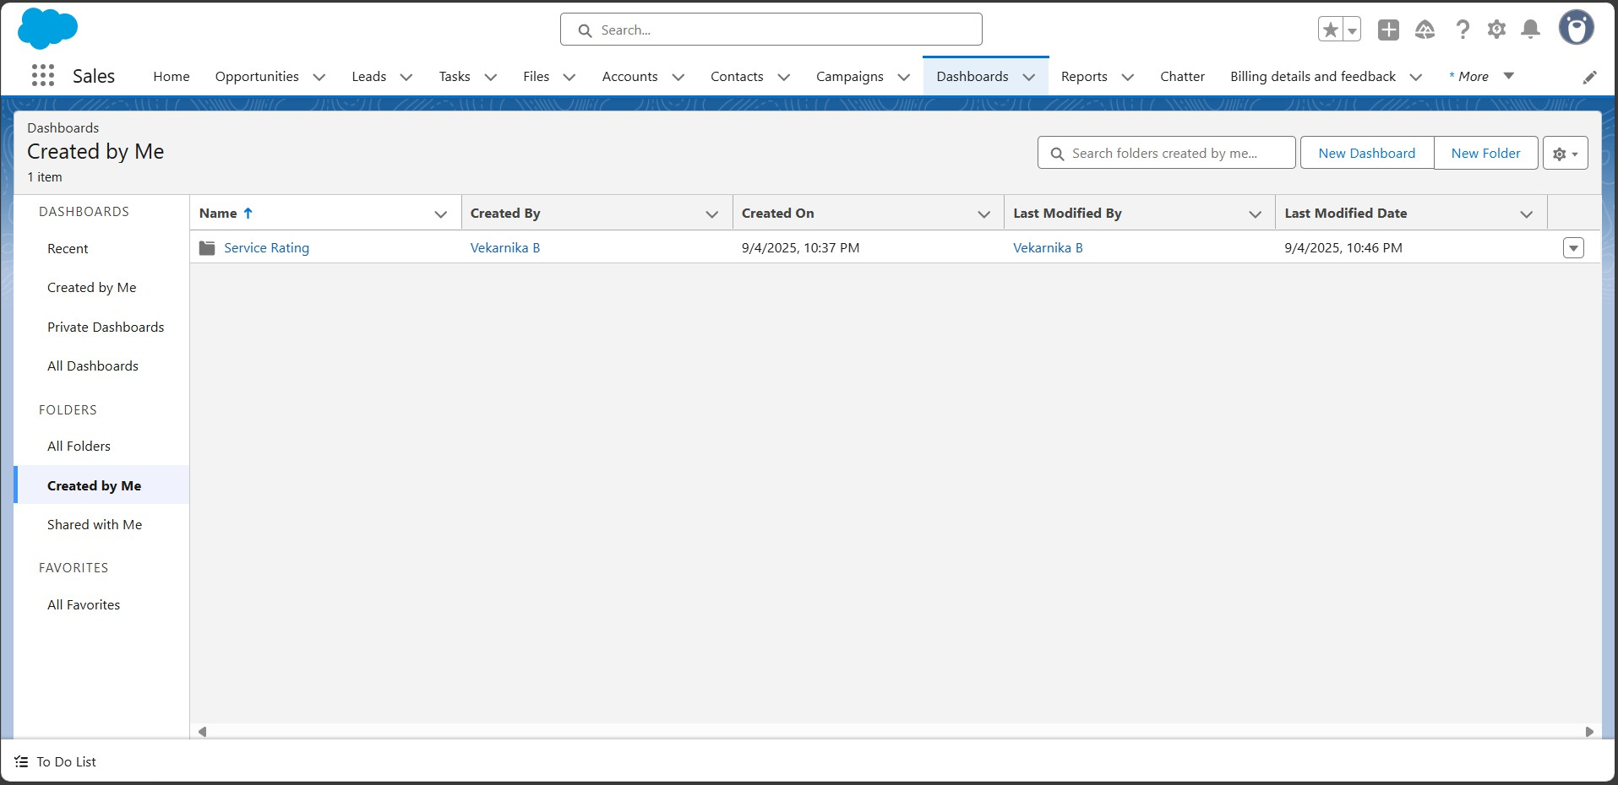

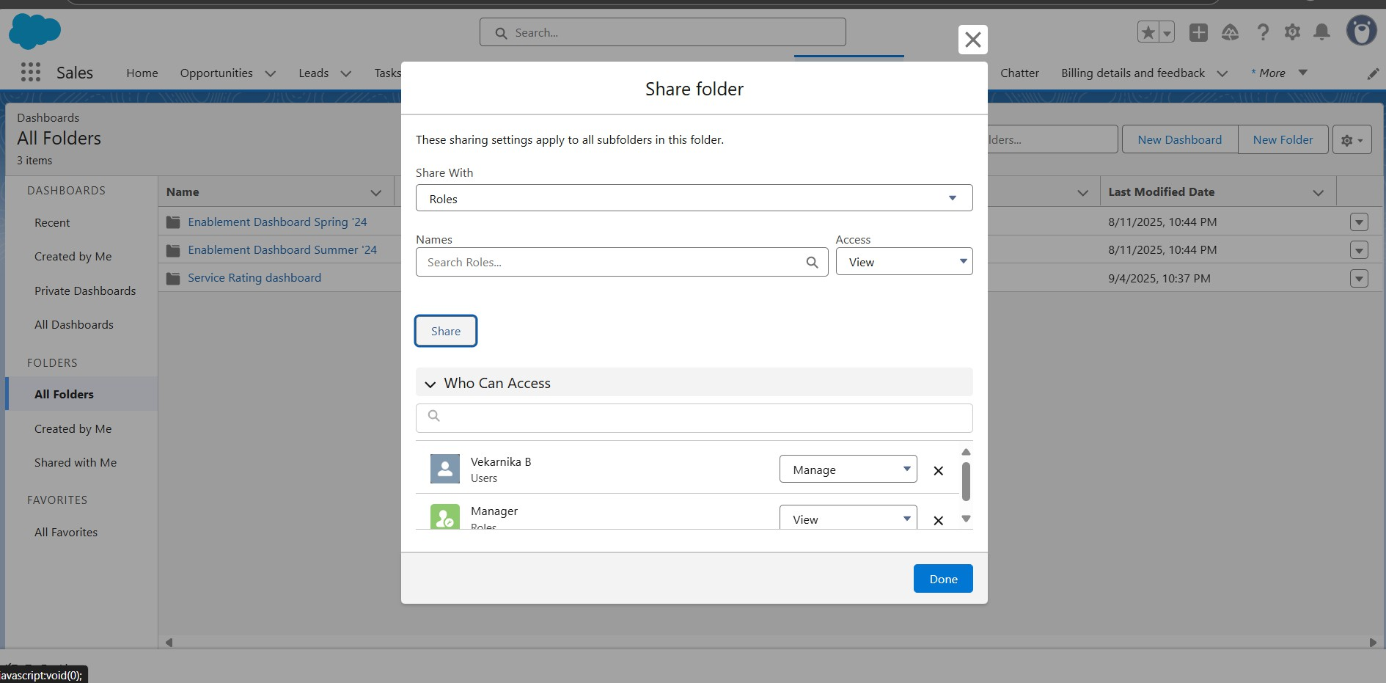

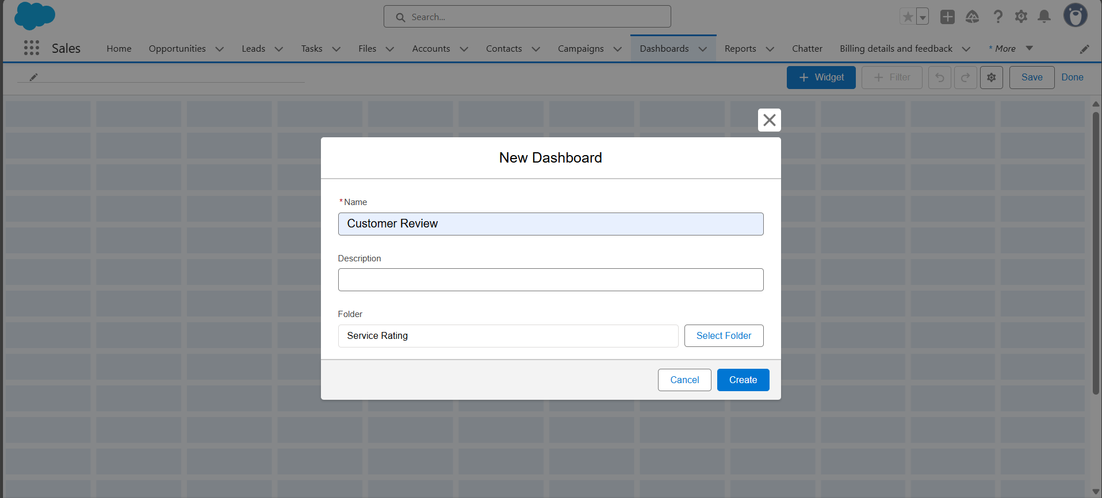

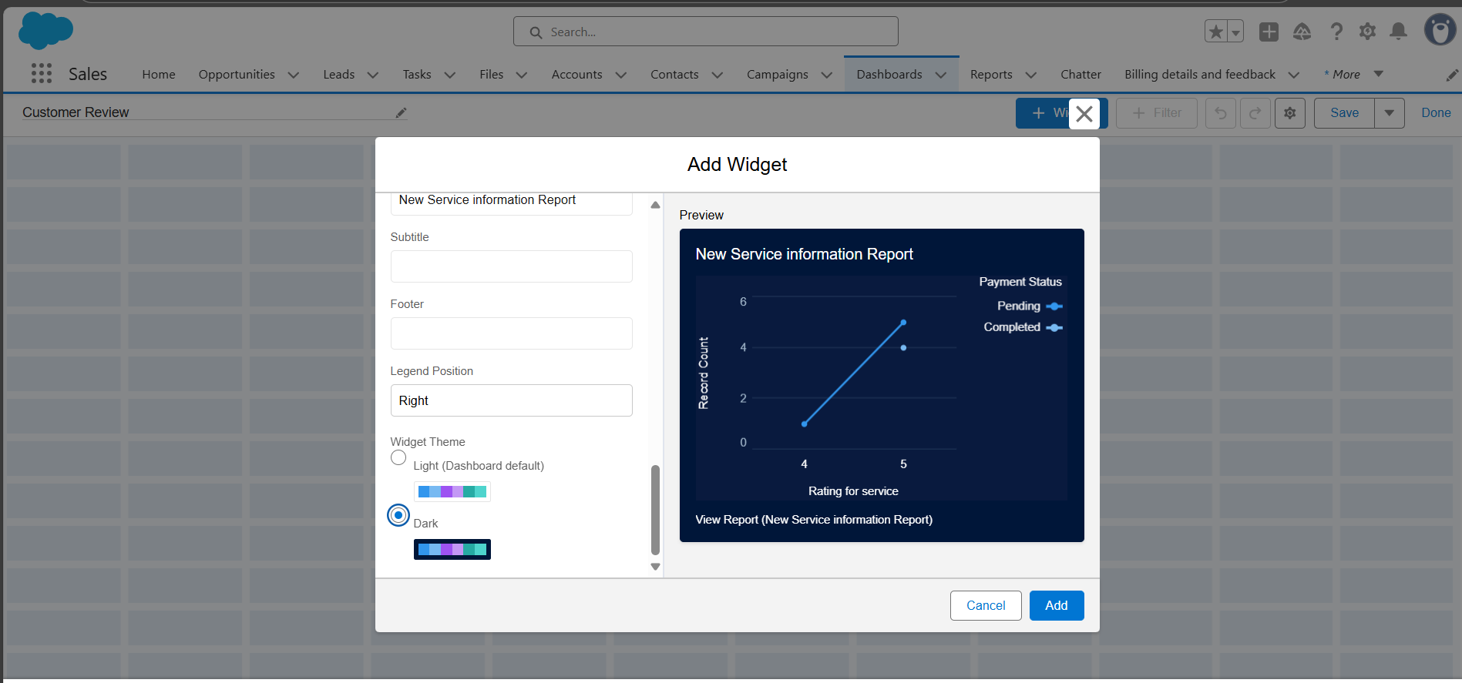

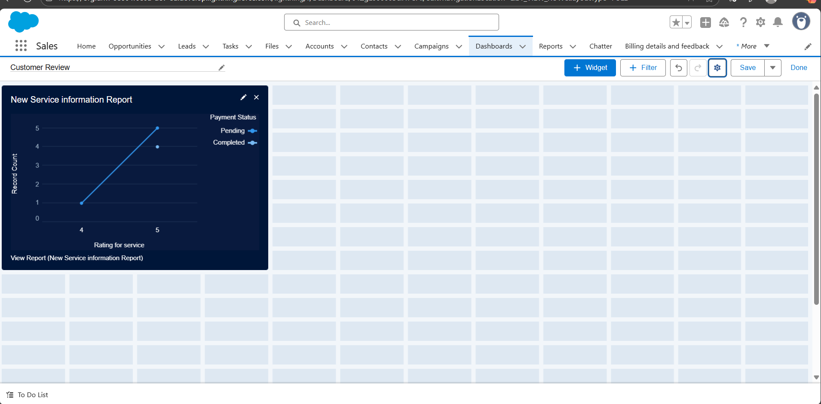

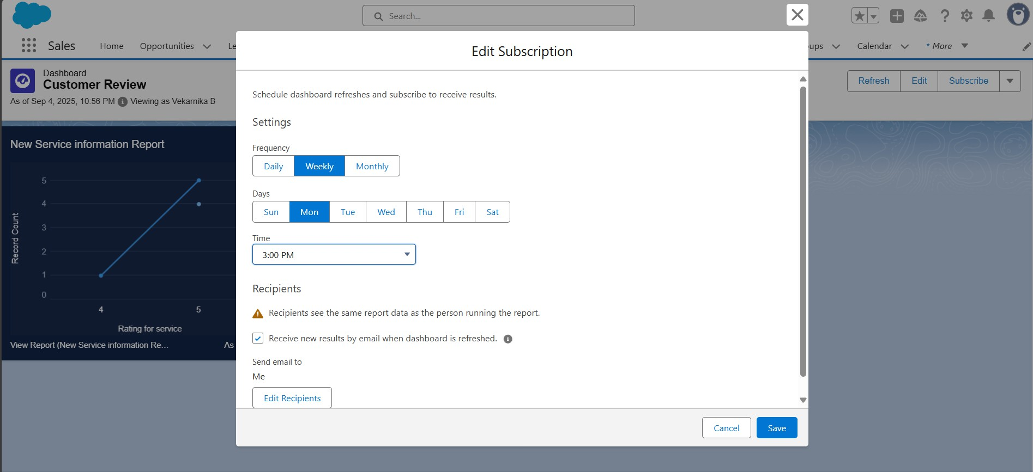

# ADVANTAGES & DISADVANTAGES

**Advantages of Garage Management System:**

* **Centralized Data Management** – All customer, vehicle, and service records are stored in one place, improving accessibility and reducing data duplication.
* **Improved Customer Experience** – Automated service reminders, transparent billing, and quick updates enhance customer trust and satisfaction.
* **Operational Efficiency** – Streamlines job scheduling, inventory tracking, and billing, reducing manual effort and errors.
* **Scalability** – Built on Salesforce, the system can easily expand with additional modules or features as the business grows.
* **Integration Capabilities** – Seamlessly integrates with CRM, payment systems, and other Salesforce apps for smooth workflows.
* **Analytics & Reporting** – Real-time dashboards and reports help managers track performance, revenue, and customer trends.

**Disadvantages of Garage Management System:**

* **Cost of Implementation** – Licensing, customization, and ongoing Salesforce subscription costs may be high for small garages.
* **Learning Curve** – Staff may require training to adapt to Salesforce’s interface and features.
* **Customization Dependency** – Advanced requirements often need Salesforce developers/consultants, increasing dependency.
* **Internet Reliance** – Being a cloud-based system, uninterrupted internet is essential for smooth operations.
* **Overhead for Small Businesses** – Smaller repair shops may find the system more complex than needed for basic operations.

# CONCLUSION

The Garage Management System streamlines operations, enhances customer satisfaction, and supports business growth, making it a reliable solution for modern automotive repair facilities.

# RESULTS

**Output Screenshots**

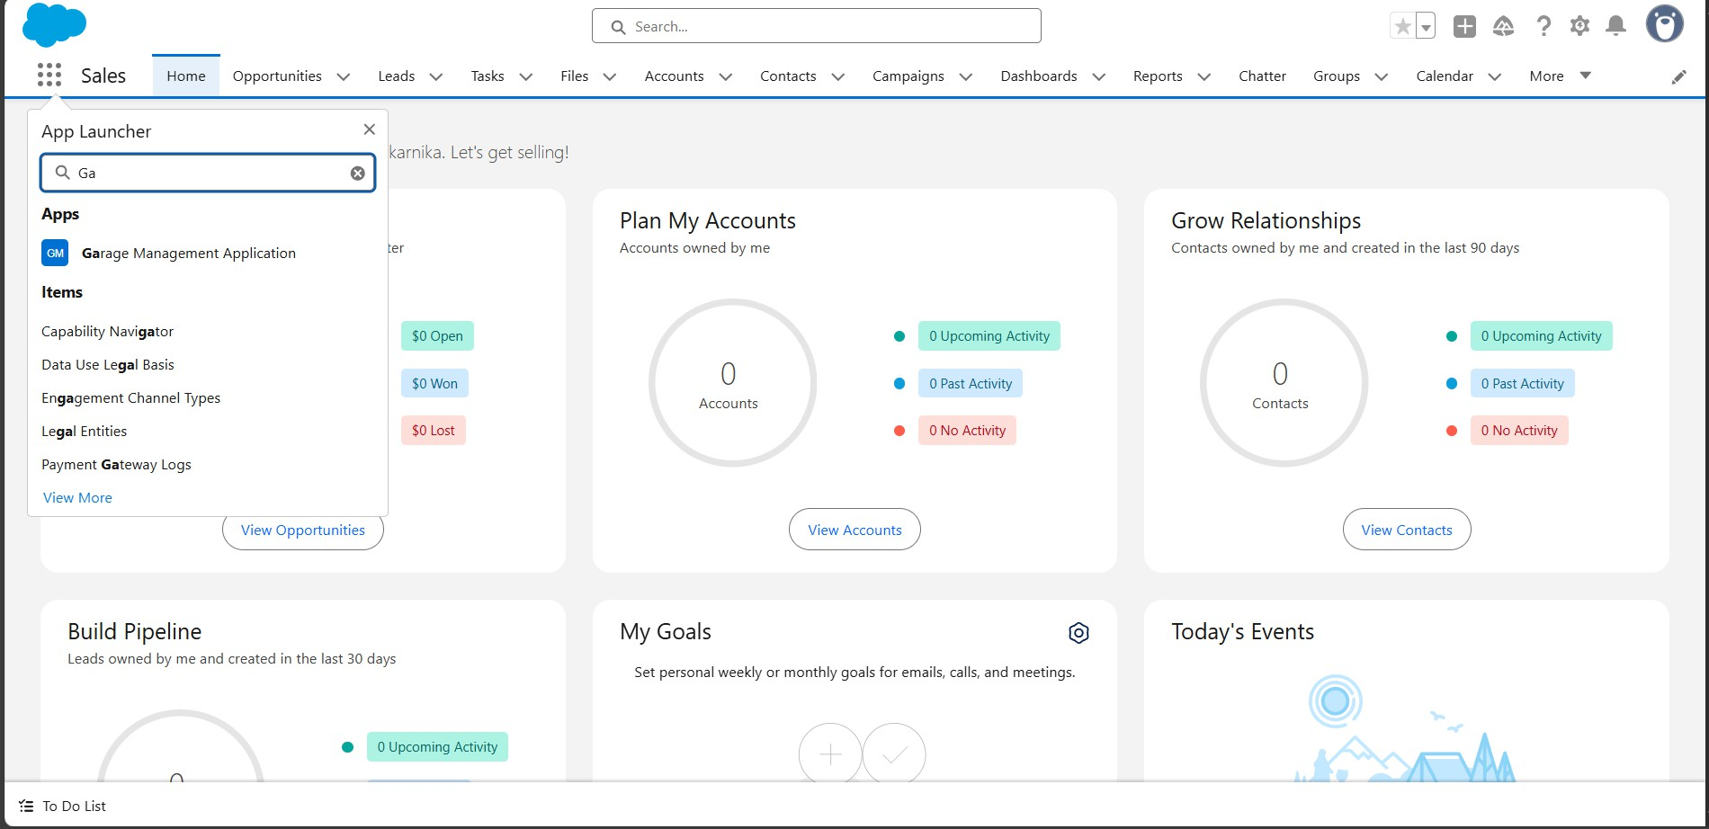

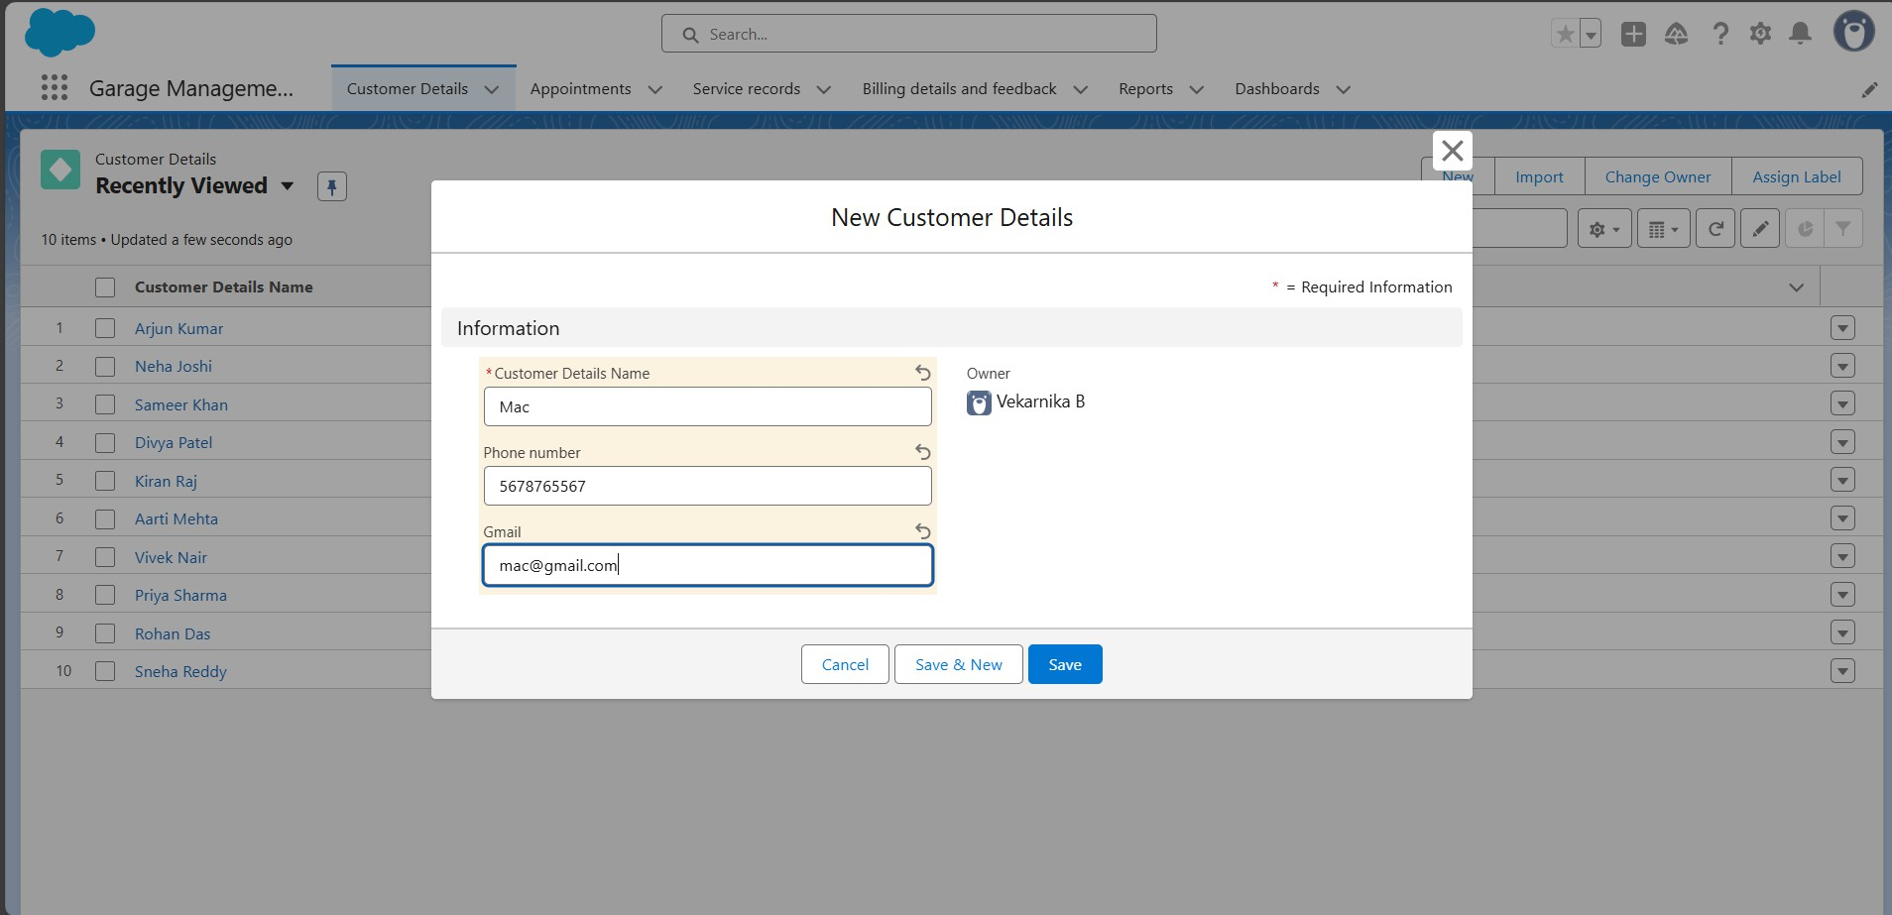

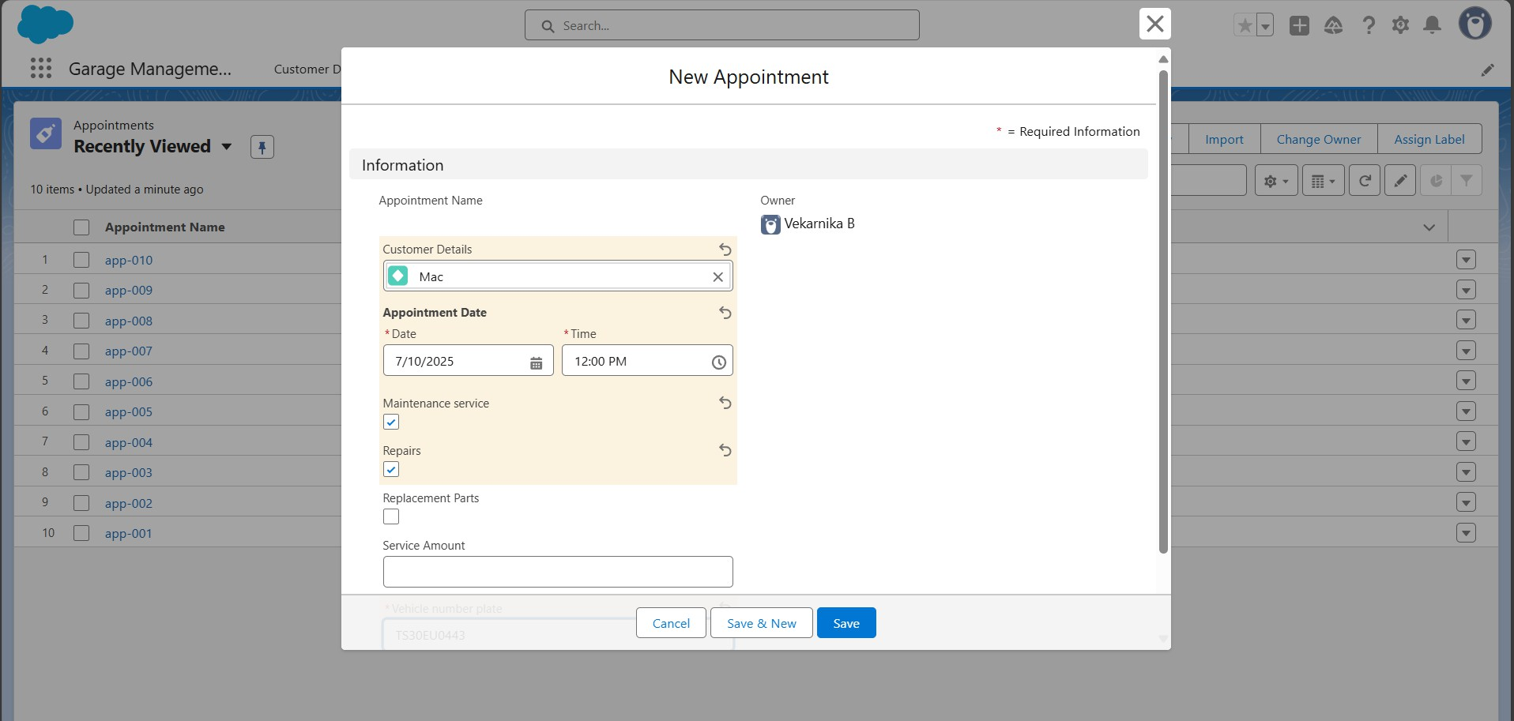

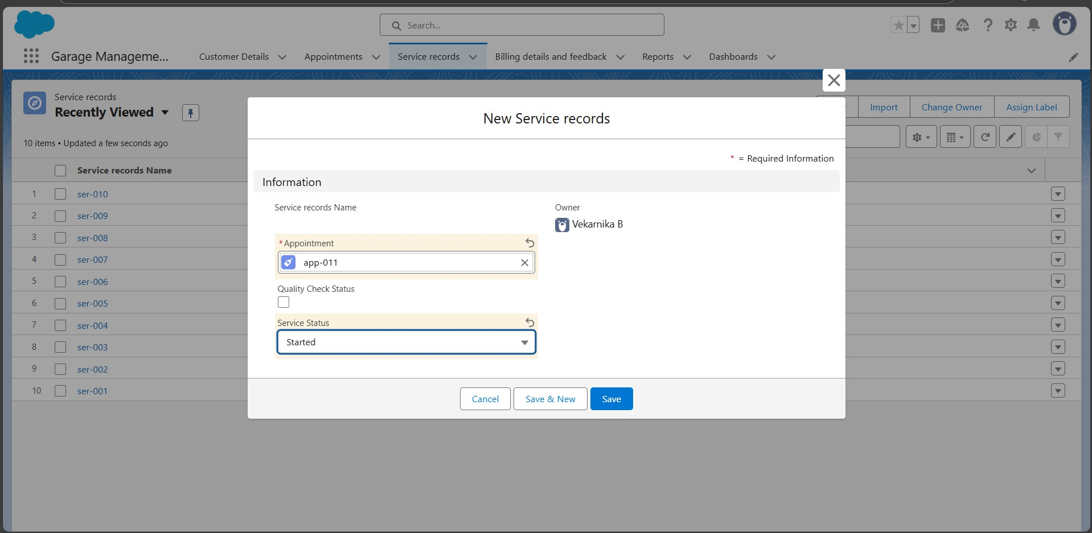

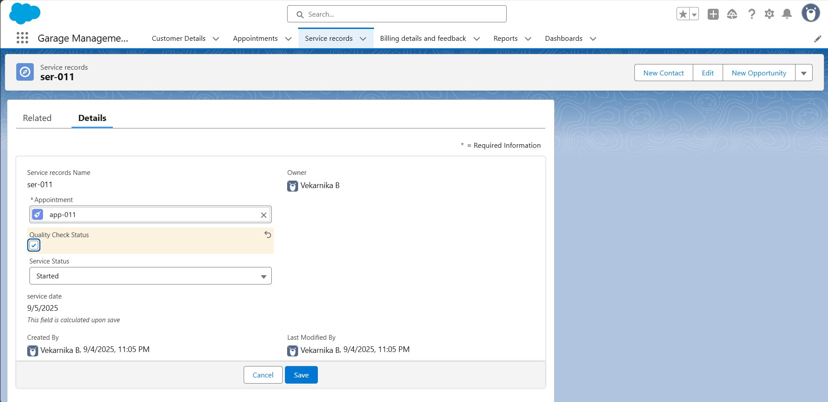

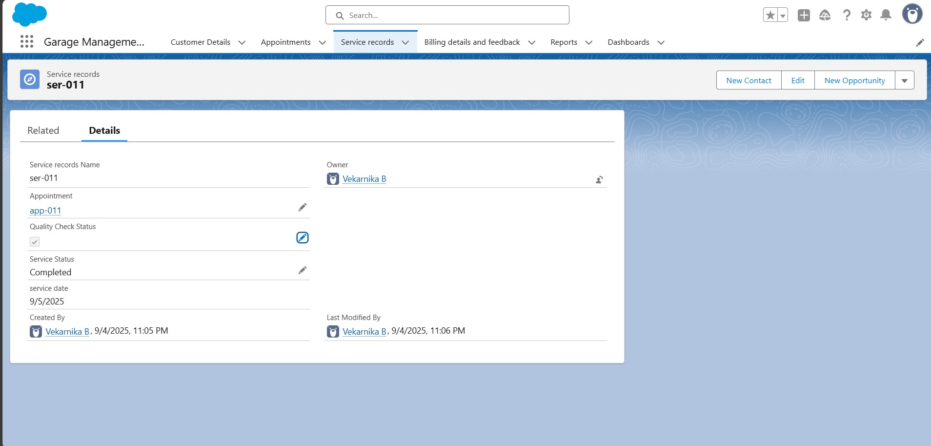

# APPENDIX

* Source Code: Provided in Apex Classes and Triggers

### To create apex class (AmountDistributionHandler)

public class AmountDistributionHandler {

public static void amountDist(list<Appointment c> listApp){ list<Service_records_c> serList = new list <Service_records_c>();

for(Appointment c app : listApp){

if(app.Maintenance_service_c == true && app.Repairsc == true && app.Replacement_Parts_c == true){

app.Service_Amount c = 10000;

}

else if(app.Maintenance_service_c == true && app.Repairs_c ==

true){

app.Service_Amount c = 5000;

}

else if(app.Maintenance_service_c == true && app.Replacement_Parts_c == true){

app.Service_Amount c = 8000;

}

else if(app.Repairs_c == true && app.Replacement_Parts_c ==

true){

app.Service_Amount c = 7000;

}

else if(app.Maintenance_service c == true){ app.Service_Amount c = 2000;

}

else if(app.Repairs c == true){ app.Service_Amount c = 3000;

}

else if(app.Replacement_Parts c == true){ app.Service_Amount c = 5000;

}

}

}

}

### AmountDistribution - Apex Trigger:

trigger AmountDistribution on Appointment c (before insert, before update) {

if(trigger.isbefore && trigger.isinsert || trigger.isupdate){ AmountDistributionHandler.amountDist(trigger.new);

}

}